

**Victorian Lung Cancer Registry**

**QUALITY INDICATOR REPORT**

**1 July 2012 to 30 June 2013**

**Contents**

Summary 2

Background 2

VLCR Governance 3

Methods 4

Results 5

Process and diagnostic indicators 6

Surgical indicators 17

Chemotherapy and radiotherapy indicators 21

Active treatment indictors 24

Palliative care indicators 25

Survival 26

VLCR Personnel 27

Conclusions 28

Future directions 28

References 29

Appendices 30

Appendix A: VLCR Quality indicators 30

Appendix B: VLCR Governance 32

Steering Committee 32

Management Committee 33

Appendix C: Investigation into VLCR case ascertainment completeness 34

Appendix D: VLCR Escalation policy 35

Appendix E: VLCR Publications, presentations and awards 37

Appendix F: VLCR Funding 38

Appendix G: Glossary 38

# Summary

* The VLCR is a pilot disease quality registry designed to help improve the quality of care delivered to Victorians with lung cancer
* The registry aims to collect management, treatment and outcome data on all new cases of lung cancer
* Benchmarking quality indicators allows closure of the quality cycle: plan, implement, assess, review
* 25 Quality Indicators selected following extensive literature review and evaluation of established clinical practice guidelines
* 8 Victorian Hospitals established and trained: 6 metropolitan, 2 regional, 3 public, 3 private
* Minimum dataset established with standardised data collection across sites
* 690 eligible and consenting patients from 1 July 2012 to 31 June 2013
* Data collected on 25% of total new cases in Victoria

# Background

Lung cancer remains a major disease burden in Victoria and requires a complex and multidisciplinary approach to ensure optimal care and outcomes. To date, no uniform mechanism is available to capture standardised population based outcomes to enable performance benchmarking. The establishment of such a data platform is therefore a primary requisite, enabling description of process and outcome in lung cancer care and to drive improvement in the quality of care provided to individuals with lung cancer.

The VLCR was developed in early 2011 to capture outcomes, patterns of care and quality of care delivered to patients diagnosed with lung cancer in Victoria and to determine the extent to which patient and health-related factors impact on variation in survival. The registry was developed as a pilot project over three years and established in eight Victorian hospitals (5 public, 3 private, 6 metropolitan, 2 regional) together comprising 25% of all lung cancer notifications in Victoria (Victorian Cancer Registry 2011).

# VLCR Governance

The Governance of VLCR was established to meet the standards outlined within the operating principles by the Australian Commission for Safety and Quality in Healthcare.

The registry is governed by a Steering Committee, which is comprised of a consumer representative (n=1), thoracic physicians (3), thoracic surgeon (1), radiation oncologists (2), medical oncologists (2), palliative care physician (1), general practice doctor (1), cancer nurse (1), epidemiologists (n=3), a basic scientist (1), representatives from health departments in bioinformatics (1), tissue biobank (1), health department administration (1) and from the state cancer registry (1).

The Management Committee is responsible for managing day-to-day aspects of the clinical register. Data quality measures are reported regularly to the management committee.

(See Appendix B: VLCR Committee members)

STEERING COMMITTEE

**Responsibilities:**

* Develop and ensure registry meets overall objectives
* Facilitate policy support for issues identified by the Management Committee
* Establish an outlier policy and ensure that it is enacted
* Ensure that Management Committee meets its reporting obligations to hospitals, clinicians and working groups
* Review and advise on registry output
* Establish data access policy and ensure that it is enacted
* Monitor data quality management processes
* Review and provide advice on communication strategy

**STEERING COMMITTEE**

Comprises

* senior clinicians - leadership role
* representation from:
* clinician stakeholders
* epidemiology
* bench scientist
* Victorian Cancer Registry
* Biogrid / Biobank
* Department of Health
* professional society/ies
* consumer

MANAGEMENT COMMITTEE

**Responsibilities:**

* Management of staff, work duties and budget
* Ensure that data collection & quality processes function effectively
* Ensure data issues are managed in a timely and effective manner
* Arrange for timely and appropriate statistical analyses
* Ensure compliance with requirements of ethics committees and legislation
* Provide reports to Steering Committee
* Liaise with funding bodies and stakeholders
* Provide support for the function of the various scientific working groups

**MANAGEMENT COMMITTEE**

Comprises

* at least 2 clinical specialists
* at least 2 members of the Data Management Unit
* Data custodian

**Scientific Working Groups**

* Comprises clinicians with interest in area and ≥ 1 member of the data management centre
* Report to the Management Committee
* Submit report/s to Steering Committee as agreed

**Data Management Unit**

* Comprises registry data custodian and data collectors
* Report to the Management Committee

*Fig 1: Overview of VLCR governance structure*  
Fig

# Methods

Quality indicators (Appendix A) were developed by an expert working group comprising representation from thoracic surgery, respiratory medicine, medical oncology, radiation oncology, palliative care and epidemiology following an extensive review of Australian and international clinical practice guidelines.

Case ascertainment was established by regular institutional reporting of ICD-10 discharge coding. An Investigation into gaps in the current case ascertainment was completed at one public and one private metropolitan hospital. (Appendix C). The recruitment strategy uses opt out consent and waiver (for death) model which has resulted in capture of 94% of potentially eligible patients.

The collection of a standardised minimum data set optimises capacity for population-based data capture. This data set provides scope for the construction of a risk-adjusted model for outcomes. A data access policy and a mechanism for escalation policy for outcome outliers have been established. (See Appendix D)

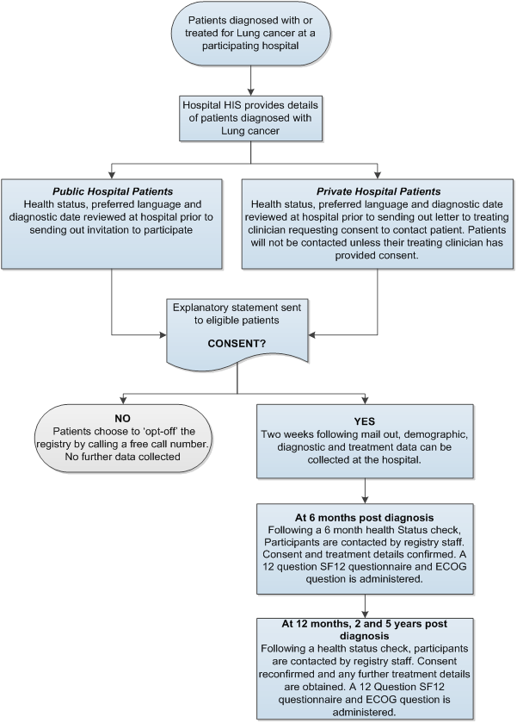

*Fig 2: VLCR Registry Schema*  
Fig

# Results

Recruitment numbers outlined below represent notifications to the VLCR from 8 participating healthcare institutions in Victoria. Quality indicators described throughout this analysis represent data collected on 690 eligible and consenting patients from July 01, 2012 to June 31, 2013.

|  |  |  |  |  |  |  |  |  |  |
| --- | --- | --- | --- | --- | --- | --- | --- | --- | --- |
|  | **Metropolitan Public** | | | **Metropolitan Private** | | | **Regional** | |  |
| **Institution** | **A** | **B** | **C** | **D** | **E** | **F** | **G** | **H** | **Total** |
| Registrations | 105 | 155 | 124 | 54 | 101 | 100 | 47 | 44 | 730 |
| Opt out (%) | 6 (5.7) | 12 (7.7) | 5 (4.0) | 2 (3.7) | 4 (4.0) | 7 (7.0) | 2 (4.3) | 3 (6.8) | 41 (5.6) |
| Inclusions | 99 | 143 | 119 | 52 | 97 | 93 | 45 | 41 | 689 |
| Deaths | 49 | 57 | 47 | 14 | 32 | 36 | 25 | 21 | 281 |
| Mortality % | 49.5 | 39.9 | 39.5 | 26.9 | 33.0 | 38.7 | 55.6 | 51.2 | 40.8 |

**Interpreting the funnel plots below:**

The **horizontal axis** (x-axis) measures the number of events being examined. For example, in this report that might refer to the documentation of the clinical stage in the medical record or theproportion of patients documented with loss of weight at diagnosis

The **vertical axis** (y-axis) measures treatment effect. For example, in this report this might represent the % of notes where documentation of clinical stage was recorded by hospital/clinician or the % of patients with documented loss of weight in the medical record.

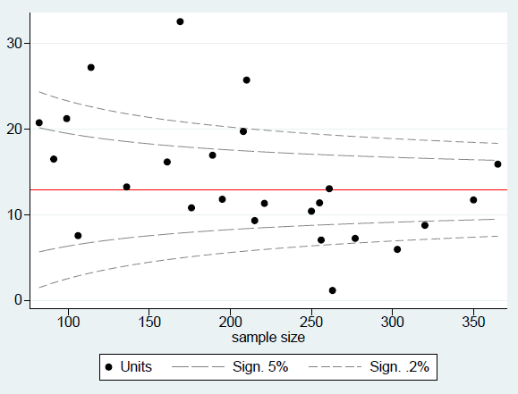A point estimate (**black dots**) of the treatment effect for a given patient number is then plotted for each hospital contributing to the registry.

Upper 99.8% control limit ≈3SD

Population mean

Upper 95% control limit ≈2SD

The **red line** represents the pooled average % treatment effect for all hospitals combined.

As samples/patient numbers get larger, the closer to the pooled estimate they become, as represented by the convergence of **dashed contour lines** (themselves representing 5% and 0.2% significance respectively).

Individual Units/patients

*Please Note: sites with n<10 patients will not be represented in funnel plots

# Process and diagnostic indicators

Upper 99.8% control limit ≈3SD

**QI 1: NUMBER OF PATIENTS WHERE TIME FROM REFERRAL DATE TO DIAGNOSIS IS LESS THAN 28 DAYS.**

|  |  |  |
| --- | --- | --- |
| No. | Numerator | Denominator |
| 1 | Number of patients where time from referral date to diagnosis is less than 28 days | Total number of patients in Registry with a referral date available |

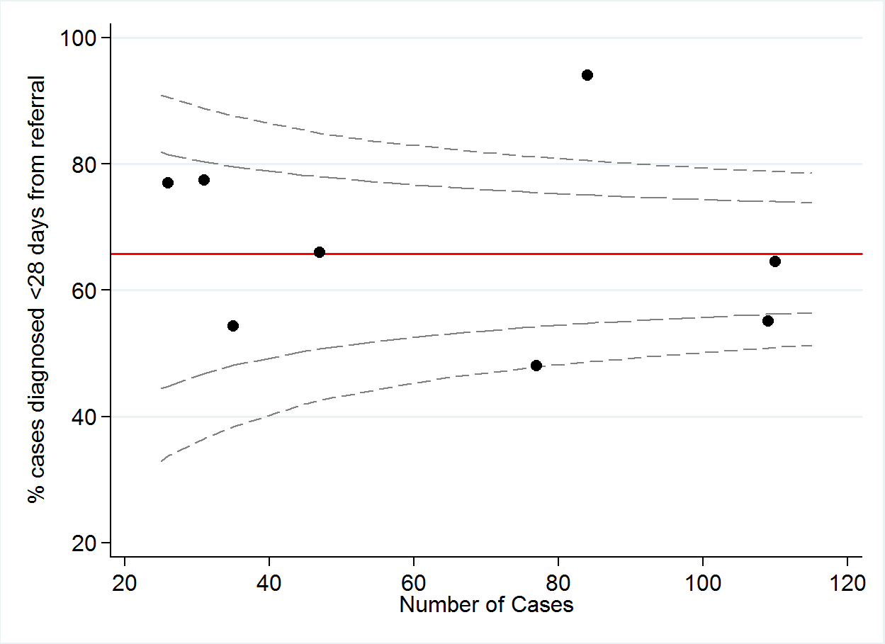

|  |  |  |  |  |  |  |  |  |  |
| --- | --- | --- | --- | --- | --- | --- | --- | --- | --- |
|  | A | B | C | D | E | F | G | H | TOTAL |
| Numerator | 37 | 60 | 71 | 31 | 19 | 79 | 24 | 20 | 341 |
| Denominator | 77 | 109 | 110 | 47 | 35 | 84 | 31 | 26 | 519 |
| % | 48 | 55 | 65 | 66 | 54 | 94 | 77 | 77 | 66* |

\**mean of proportions (%)*

**QI 2: NUMBER OF PATIENTS WHERE TIME FROM DIAGNOSIS DATE TO FIRST TREATMENT DATE IS LESS THAN 14 DAYS.**

|  |  |  |
| --- | --- | --- |
| No. | Numerator | Denominator |
| 2 | Number of patients where time from diagnosis date to first treatment date is less than 14 days | Total number of patients in Registry receiving treatment |

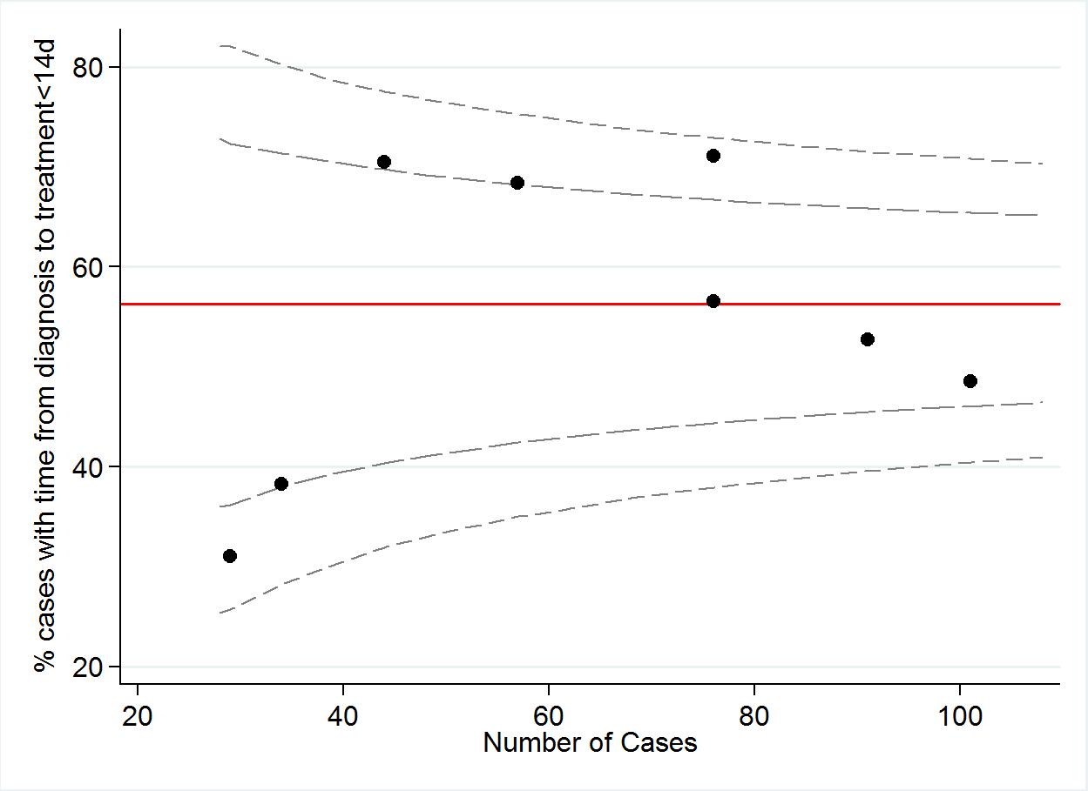

|  |  |  |  |  |  |  |  |  |  |
| --- | --- | --- | --- | --- | --- | --- | --- | --- | --- |
|  | A | B | C | D | E | F | G | H | TOTAL |
| Numerator | 43 | 49 | 48 | 31 | 39 | 54 | 13 | 9 | **286** |
| Denominator | 76 | 101 | 91 | 44 | 57 | 76 | 34 | 29 | **508** |
| % | 57 | 49 | 53 | 70 | 68 | 71 | 38 | 31 | **56** |

**QI 2A: NUMBER OF PATIENTS WHERE TIME FROM DIAGNOSIS DATE TO SURGICAL RESECTION DATE IS LESS THAN 14 DAYS.**

|  |  |  |
| --- | --- | --- |
| No. | Numerator | Denominator |
| 2a | Number of patients where time from diagnosis date to surgical resection date is less than 14 days | Total number of patients in Registry undergoing surgical resection |

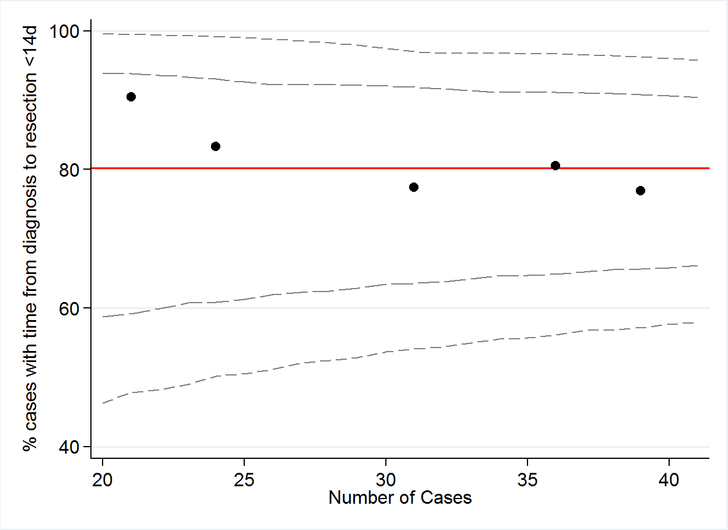**;**

|  |  |  |  |  |  |  |  |  |  |
| --- | --- | --- | --- | --- | --- | --- | --- | --- | --- |
|  | A | B | C | D | E | F | G | H | TOTAL |
| Numerator | 24 | 29 | 30 | 20 | 19 | 24 | 3 | 3 | **152** |
| Denominator | 31 | 36 | 39 | 24 | 21 | 31 | 6 | 3 | **191** |
| % | 77 | 81 | 77 | 83 | 90 | 77 | 50 | 100 | **80** |

**QI 2B: NUMBER OF PATIENTS WHERE TIME FROM DIAGNOSIS DATE TO FIRST CHEMOTHERAPY TREATMENT DATE IS LESS THAN 14 DAYS.**

|  |  |  |
| --- | --- | --- |
| No. | Numerator | Denominator |
| 2b | Number of patients where time from diagnosis date to first chemotherapy treatment date is less than 14 days | Total number of patients in Registry receiving chemotherapy treatment |

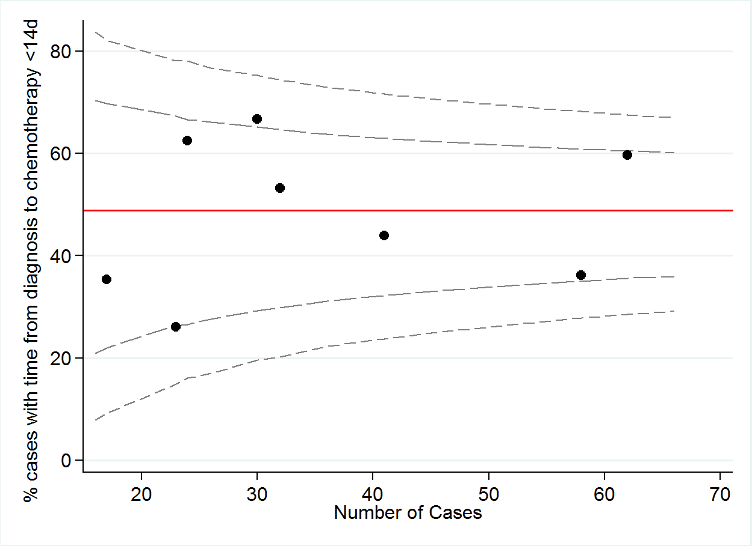

|  |  |  |  |  |  |  |  |  |  |
| --- | --- | --- | --- | --- | --- | --- | --- | --- | --- |
|  | A | B | C | D | E | F | G | H | TOTAL |
| Numerator | 17 | 18 | 21 | 6 | 15 | 37 | 20 | 6 | **140** |
| Denominator | 32 | 41 | 58 | 17 | 24 | 62 | 30 | 23 | **287** |
| % | 53 | 44 | 36 | 35 | 63 | 60 | 67 | 26 | **49** |

**QI 2C: NUMBER OF PATIENTS WHERE TIME FROM DIAGNOSIS DATE TO FIRST RADIOTHERAPY TREATMENT DATE IS LESS THAN 14 DAYS.**

|  |  |  |
| --- | --- | --- |
| No. | Numerator | Denominator |
| 2c | Number of patients where time from diagnosis date to first radiotherapy treatment date is less than 14 days | Total number of patients in Registry receiving radiotherapy treatment |

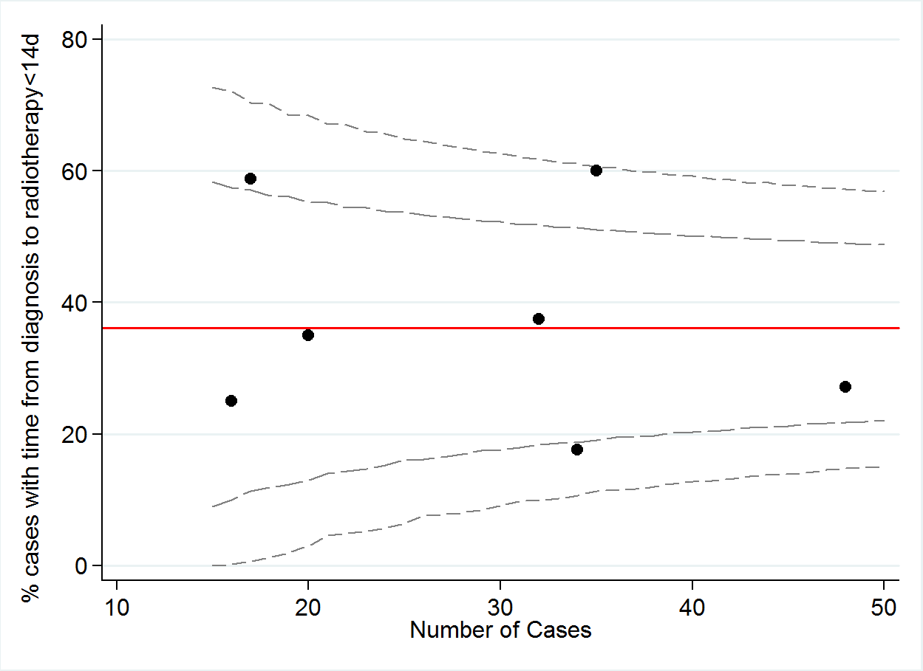

|  |  |  |  |  |  |  |  |  |  |
| --- | --- | --- | --- | --- | --- | --- | --- | --- | --- |
|  | A | B | C | D | E | F | G | H | TOTAL |
| Numerator | 12 | 13 | 6 | 1 | 10 | 21 | 7 | 4 | **74** |
| Denominator | 32 | 48 | 34 | 5 | 17 | 35 | 20 | 16 | **207** |
| % | 38 | 27 | 18 | 20 | 59 | 60 | 35 | 25 | **36** |

**QI 2D: NUMBER OF PATIENTS TREATED WITH BOTH CHEMOTHERAPY AND RADIOTHERAPY, WHERE CHEMOTHERAPY AND RADIOTHERAPY START DATES ARE WITHIN 14 DAYS OF EACH OTHER AND TIME FROM DIAGNOSIS DATE TO FIRST TREATMENT DATE IS LESS THAN 14 DAYS.**

|  |  |  |
| --- | --- | --- |
| No. | Numerator | Denominator |
| 2d | Number of patients treated with both chemotherapy and radiotherapy, where chemotherapy and radiotherapy start dates are within 14 days of each other and time from diagnosis date to first treatment date is less than 14 days | Total number of patients in Registry undergoing combined chemo-radiotherapy treatment. |

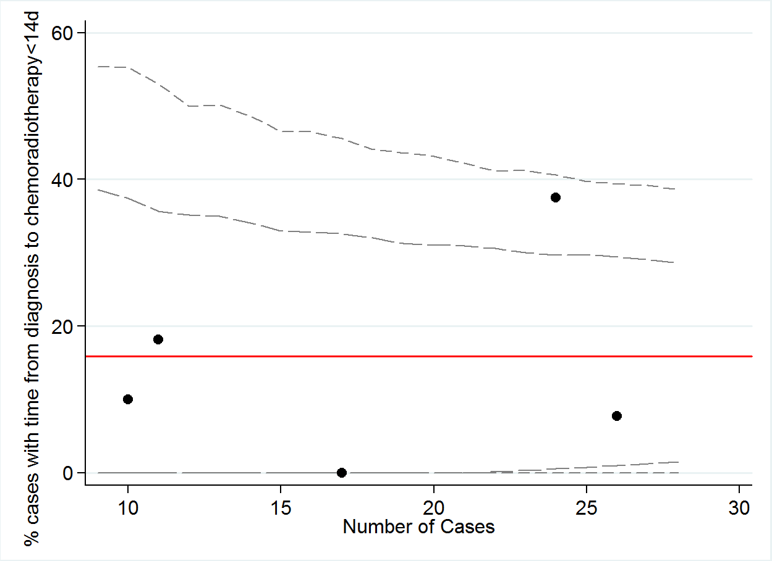

|  |  |  |  |  |  |  |  |  |  |
| --- | --- | --- | --- | --- | --- | --- | --- | --- | --- |
|  | A | B | C | D | E | F | G | H | TOTAL |
| Numerator | 2 | 2 | 0 | 1 | 4 | 9 | 1 | 1 | **20** |
| Denominator | 11 | 26 | 17 | 4 | 9 | 24 | 7 | 10 | **108** |
| % | 18 | 8 | 0 | 25 | 44 | 38 | 14 | 10 | **19** |

**QI 3: NUMBER OF PATIENTS WHERE TIME FROM DIAGNOSIS DATE TO FIRST TREATMENT DATE IS LESS THAN 42 DAYS.**

|  |  |  |
| --- | --- | --- |
| No. | Numerator | Denominator |
| 3 | Number of patients where time from diagnosis date to first treatment date is less than 42 days | Total number of patients in Registry undergoing treatment |

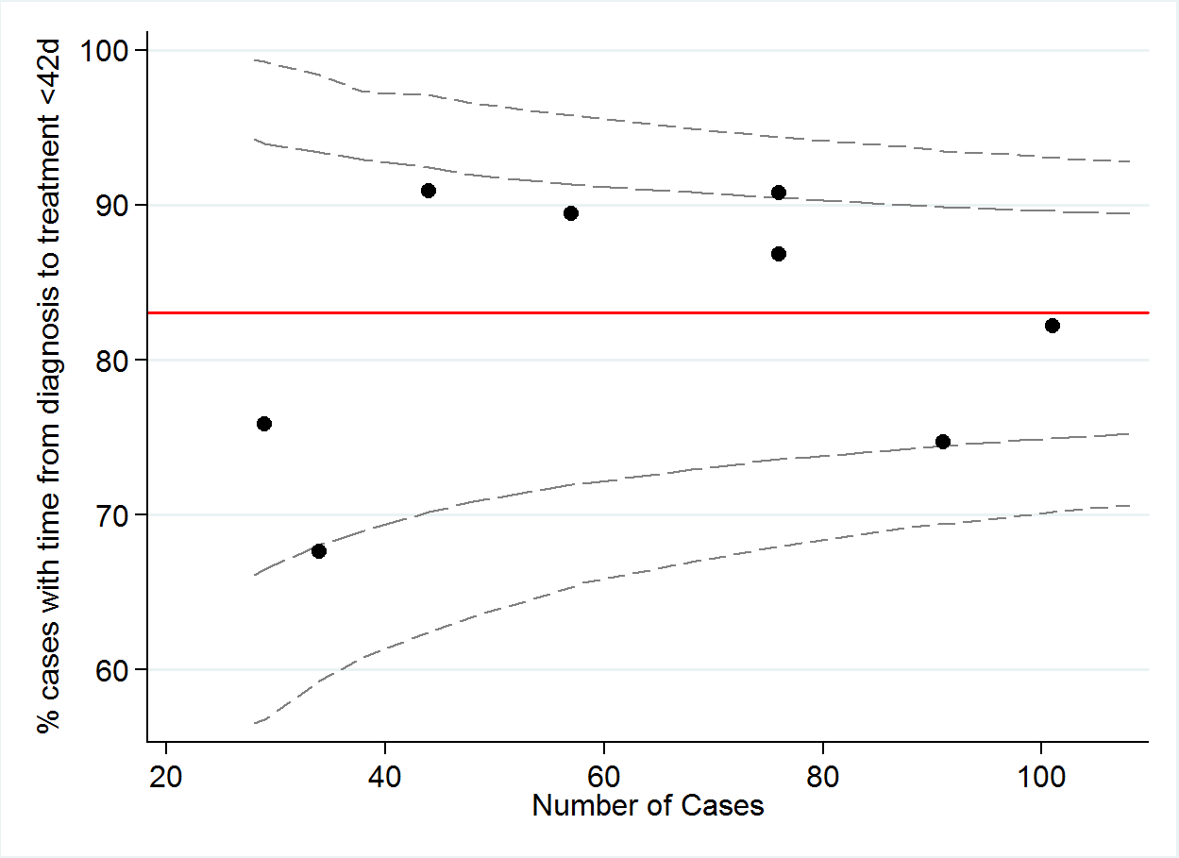

|  |  |  |  |  |  |  |  |  |  |
| --- | --- | --- | --- | --- | --- | --- | --- | --- | --- |
|  | A | B | C | D | E | F | G | H | TOTAL |
| Numerator | 66 | 83 | 68 | 40 | 51 | 69 | 23 | 22 | **422** |
| Denominator | 76 | 101 | 91 | 44 | 57 | 76 | 34 | 29 | **508** |
| % | 87 | 82 | 75 | 91 | 89 | 91 | 68 | 76 | **83** |

**QI 3A: NUMBER OF PATIENTS WHERE TIME FROM DIAGNOSIS DATE TO SURGICAL RESECTION DATE IS LESS THAN 42 DAYS.**

|  |  |  |
| --- | --- | --- |
| No. | Numerator | Denominator |
| 3a | Number of patients where time from diagnosis date to surgical resection date is less than 42 days | Total number of patients in Registry undergoing surgical resection |

**-**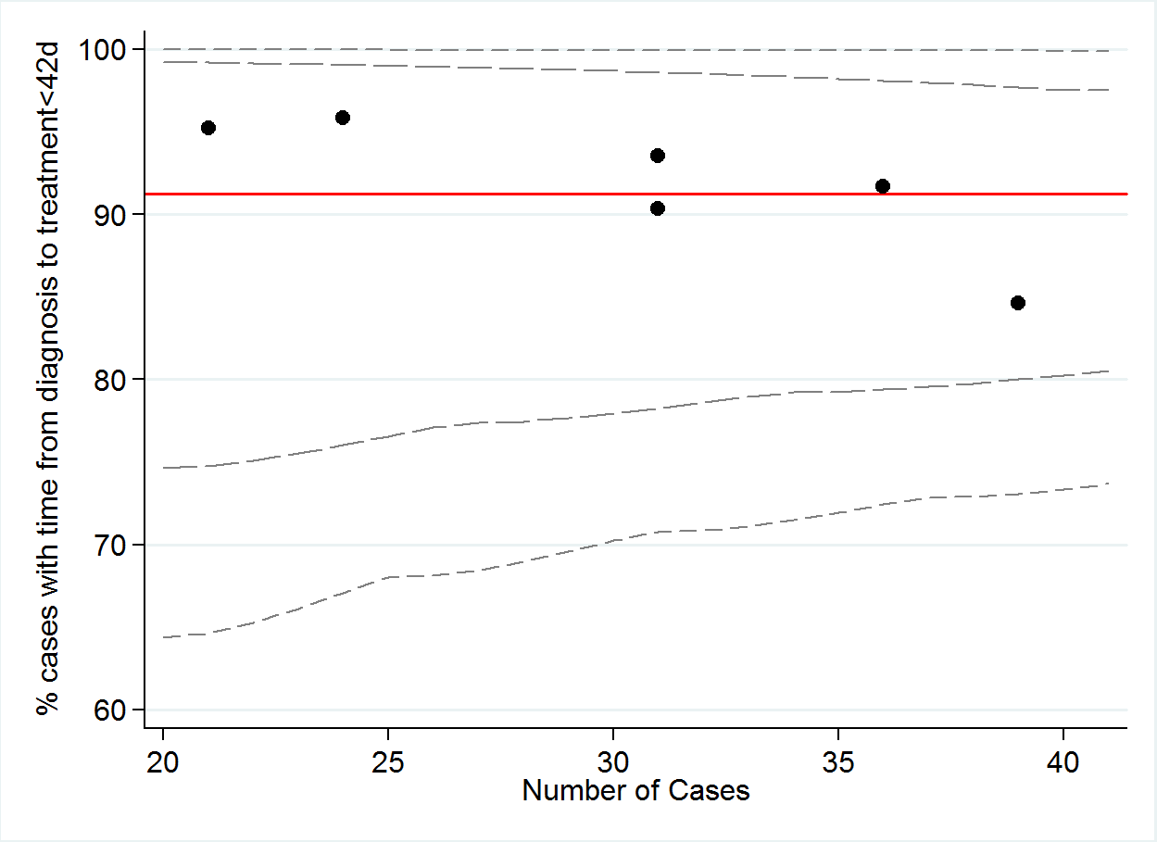

|  |  |  |  |  |  |  |  |  |  |
| --- | --- | --- | --- | --- | --- | --- | --- | --- | --- |
|  | A | B | C | D | E | F | G | H | TOTAL |
| Numerator | 29 | 33 | 33 | 23 | 28 | 20 | 4 | 3 | **173** |
| Denominator | 31 | 36 | 39 | 24 | 31 | 21 | 6 | 3 | **191** |
| % | 94 | 92 | 85 | 96 | 90 | 95 | 67 | 100 | **91** |

**QI 3B: NUMBER OF PATIENTS WHERE TIME FROM DIAGNOSIS DATE TO FIRST CHEMOTHERAPY TREATMENT DATE IS LESS THAN 42 DAYS.**

|  |  |  |
| --- | --- | --- |
| No. | Numerator | Denominator |
| 3b | Number of patients where time from diagnosis date to first chemotherapy treatment date is less than 42 days | Total number of patients in Registry undergoing chemotherapy |

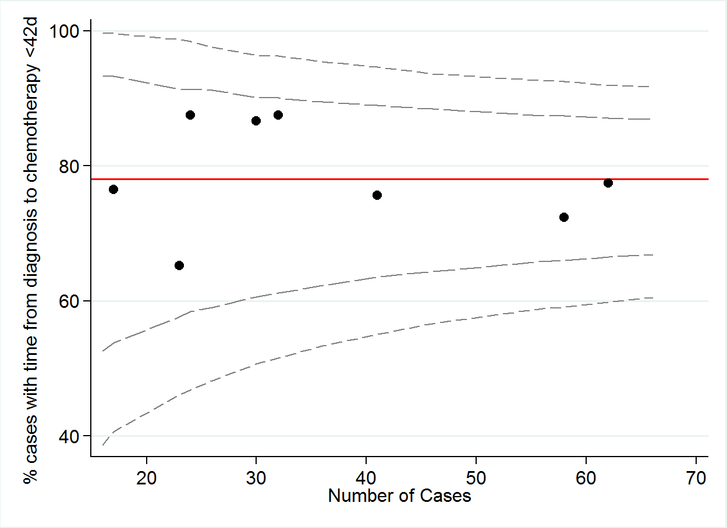

|  |  |  |  |  |  |  |  |  |  |
| --- | --- | --- | --- | --- | --- | --- | --- | --- | --- |
|  | A | B | C | D | E | F | G | H | TOTAL |
| Numerator | 28 | 42 | 31 | 21 | 26 | 48 | 13 | 15 | **224** |
| Denominator | 32 | 58 | 41 | 24 | 30 | 62 | 17 | 23 | **287** |
| % | 88 | 72 | 76 | 88 | 87 | 77 | 76 | 65 | **78** |

**QI 3C: NUMBER OF PATIENTS WHERE TIME FROM DIAGNOSIS DATE TO FIRST RADIOTHERAPY TREATMENT DATE IS LESS THAN 42 DAYS.**

|  |  |  |
| --- | --- | --- |
| No. | Numerator | Denominator |
| 3c | Number of patients where time from diagnosis date to first radiotherapy treatment date is less than 42 days | Total number of patients in Registry undergoing radiotherapy |

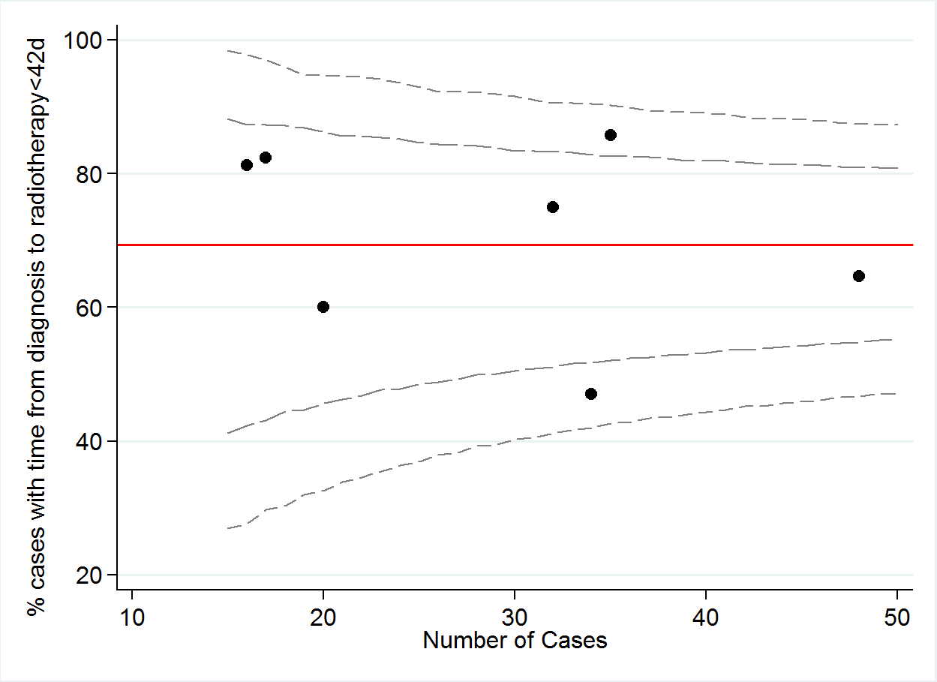

|  |  |  |  |  |  |  |  |  |  |
| --- | --- | --- | --- | --- | --- | --- | --- | --- | --- |
|  | A | B | C | D | E | F | G | H | TOTAL |
| Numerator | 24 | 31 | 16 | 3 | 14 | 30 | 12 | 13 | **143** |
| Denominator | 32 | 48 | 34 | 5 | 17 | 35 | 20 | 16 | **207** |
| % | 75 | 65 | 47 | 60 | 82 | 86 | 60 | 81 | **69** |

**QI 3D: NUMBER OF PATIENTS TREATED WITH BOTH CHEMOTHERAPY AND RADIOTHERAPY, WHERE CHEMOTHERAPY AND RADIOTHERAPY START DATES ARE WITHIN 14 DAYS OF EACH OTHER AND TIME FROM DIAGNOSIS DATE TO FIRST TREATMENT DATE IS LESS THAN 42 DAYS.**

|  |  |  |
| --- | --- | --- |
| No. | Numerator | Denominator |
| 3d | Number of patients who have been treated with both chemotherapy and radiotherapy, where chemotherapy and radiotherapy start dates are within 14 days of each other, and time from diagnosis date to first treatment date is less than 42 days | Total number of patients in Registry undergoing chemo-radiotherapy treatment |

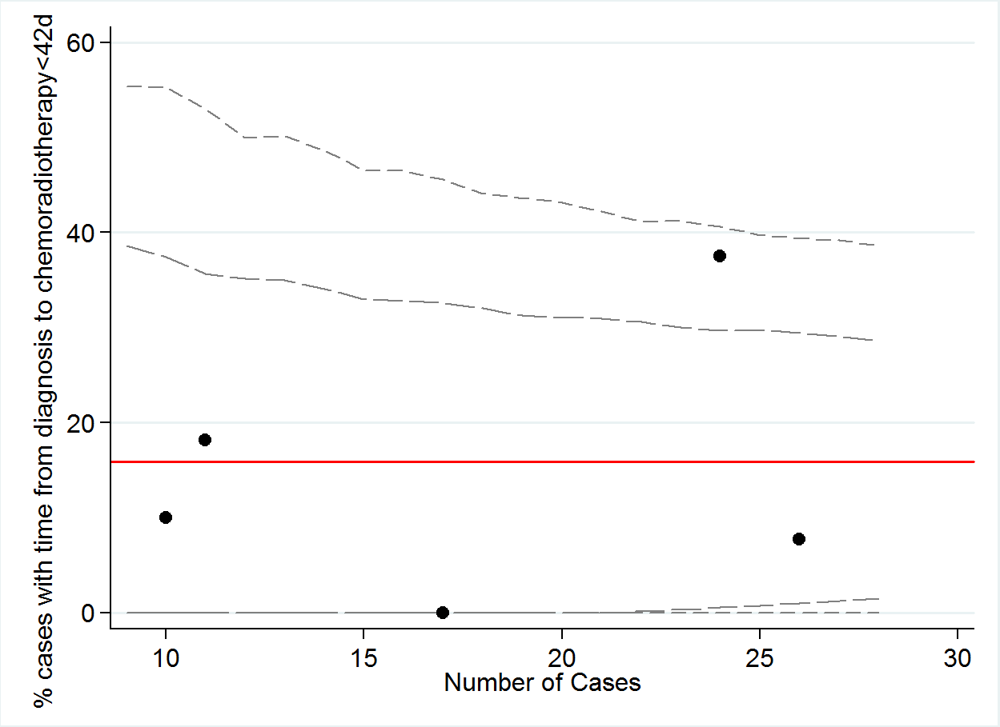

|  |  |  |  |  |  |  |  |  |  |
| --- | --- | --- | --- | --- | --- | --- | --- | --- | --- |
|  | A | B | C | D | E | F | G | H | TOTAL |
| Numerator | 2 | 2 | 0 | 1 | 4 | 9 | 1 | 1 | **20** |
| Denominator | 11 | 26 | 17 | 4 | 9 | 24 | 7 | 10 | **108** |
| % | 18 | 8 | 0 | 25 | 44 | 38 | 14 | 10 | **19** |

**QI 4: NUMBER OF PATIENTS WITH DOCUMENTED SCREENING FOR SUPPORTIVE CARE**

|  |  |  |
| --- | --- | --- |
| No. | Numerator | Denominator |
| 4 | Number of patients with documented screening for supportive care | Total number of patients in Registry |

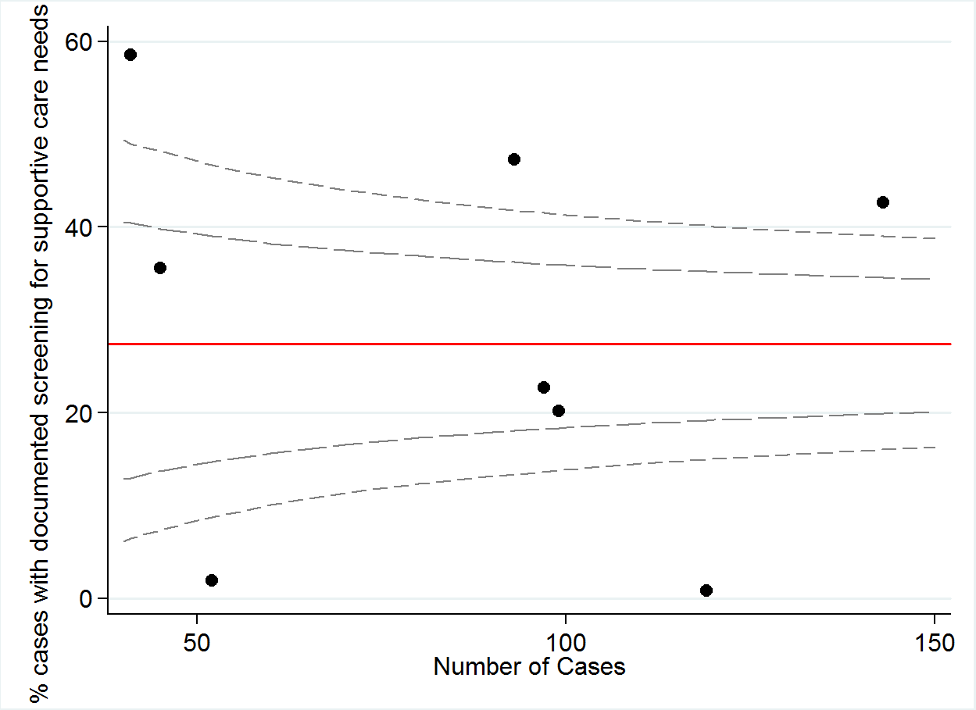

|  |  |  |  |  |  |  |  |  |  |
| --- | --- | --- | --- | --- | --- | --- | --- | --- | --- |
|  | A | B | C | D | E | F | G | H | TOTAL |
| Numerator | 20 | 61 | 1 | 1 | 22 | 44 | 16 | 24 | **189** |
| Denominator | 99 | 143 | 119 | 52 | 97 | 93 | 45 | 41 | **689** |
| % | 20 | 43 | 1 | 2 | 23 | 47 | 36 | 59 | **27** |

**QI 5: NUMBER OF PATIENTS WITH DOCUMENTED ECOG STATUS**

|  |  |  |
| --- | --- | --- |
| No. | Numerator | Denominator |
| 5 | Number of patients with documented ECOG status | Total number of patients in Registry |

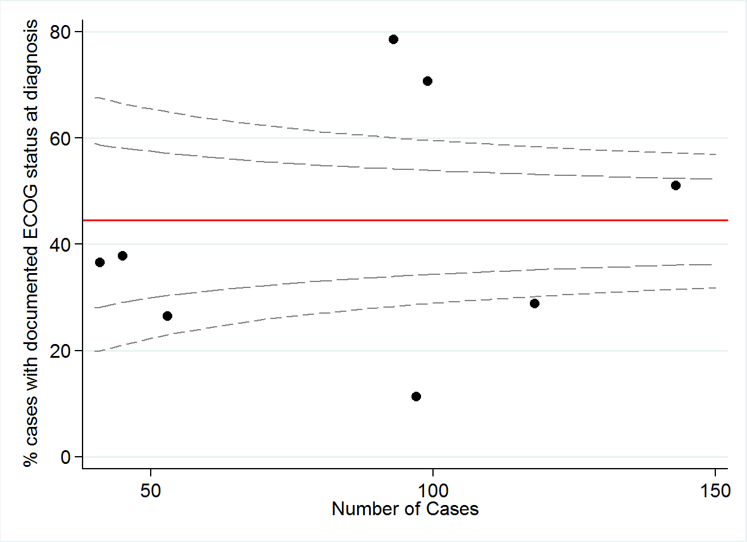

|  |  |  |  |  |  |  |  |  |  |
| --- | --- | --- | --- | --- | --- | --- | --- | --- | --- |
|  | A | B | C | D | E | F | G | H | TOTAL |
| Numerator | 70 | 73 | 34 | 14 | 11 | 73 | 17 | 15 | **307** |
| Denominator | 99 | 143 | 119 | 52 | 97 | 93 | 45 | 41 | **689** |
| % | 70 | 51 | 29 | 26 | 11 | 78 | 38 | 37 | **45** |

**QI 6: NUMBER OF PATIENTS WITH WEIGHT LOSS ASSESSMENT DOCUMENTED AT DIAGNOSIS**

|  |  |  |
| --- | --- | --- |
| No. | Numerator | Denominator |
| 6 | Number of patients with weight loss assessment documented at diagnosis | Total number of patients in Registry |

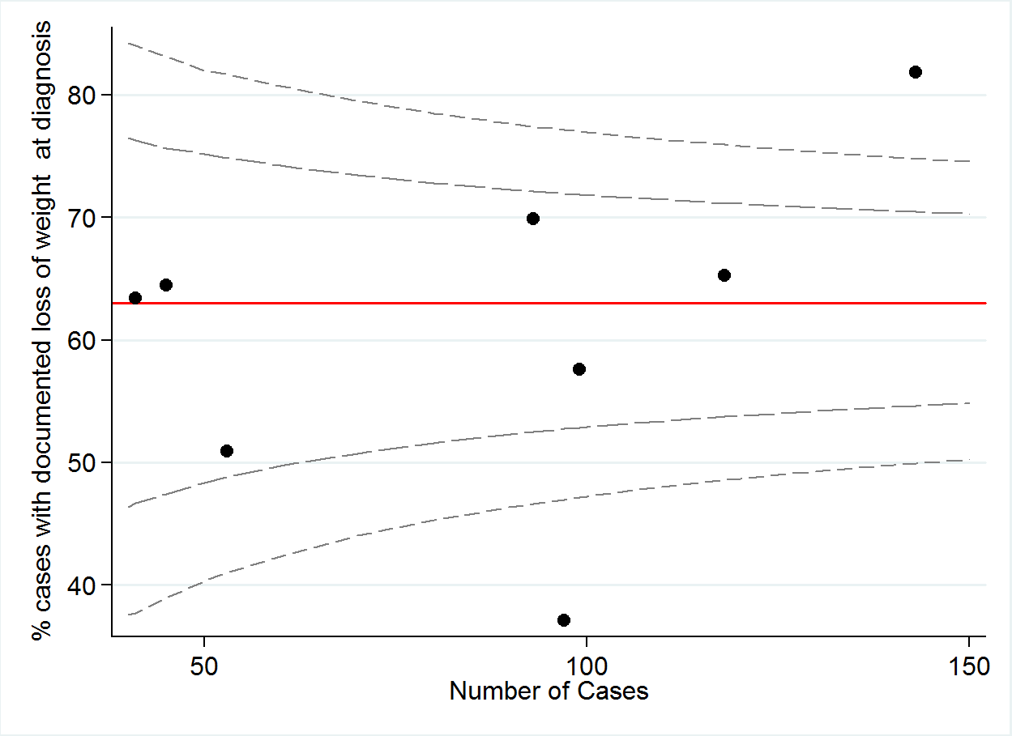

|  |  |  |  |  |  |  |  |  |  |
| --- | --- | --- | --- | --- | --- | --- | --- | --- | --- |
|  | A | B | C | D | E | F | G | H | TOTAL |
| Numerator | 57 | 117 | 77 | 27 | 36 | 65 | 29 | 26 | **434** |
| Denominator | 99 | 143 | 119 | 52 | 97 | 93 | 45 | 41 | **689** |
| % | 58 | 82 | 65 | 51 | 37 | 70 | 64 | 63 | **63** |

**QI 7: NUMBER OF PATIENTS WITH CLEARLY DOCUMENTED cTNM AT DIAGNOSIS.**

|  |  |  |
| --- | --- | --- |
| No. | Numerator | Denominator |
| 7 | Number of patients with clearly documented cTNM at diagnosis | Number of patients with NSCLC |

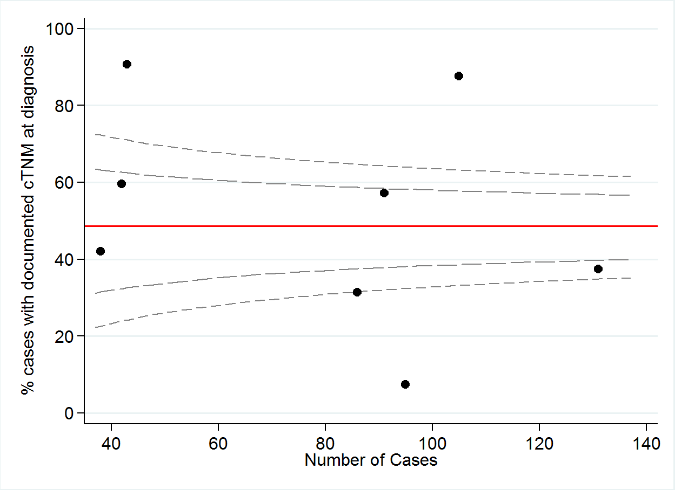

|  |  |  |  |  |  |  |  |  |  |
| --- | --- | --- | --- | --- | --- | --- | --- | --- | --- |
|  | A | B | C | D | E | F | G | H | TOTAL |
| Numerator | 52 | 49 | 92 | 39 | 7 | 27 | 25 | 16 | **307** |
| Denominator | 91 | 131 | 105 | 43 | 95 | 86 | 42 | 38 | **631** |
| % | 57 | 37 | 88 | 91 | 7 | 31 | 60 | 42 | **49** |

**QI 8: NUMBER OF NSCLC PATIENTS + SURGICAL RESECTION WITH CLEARLY DOCUMENTED PTNM.**

|  |  |  |
| --- | --- | --- |
| No. | Numerator | Denominator |
| 8 | Number of NSCLC patients + surgical resection with clearly documented pTNM | Number of patients with NSCLC who have undergone surgical resection |

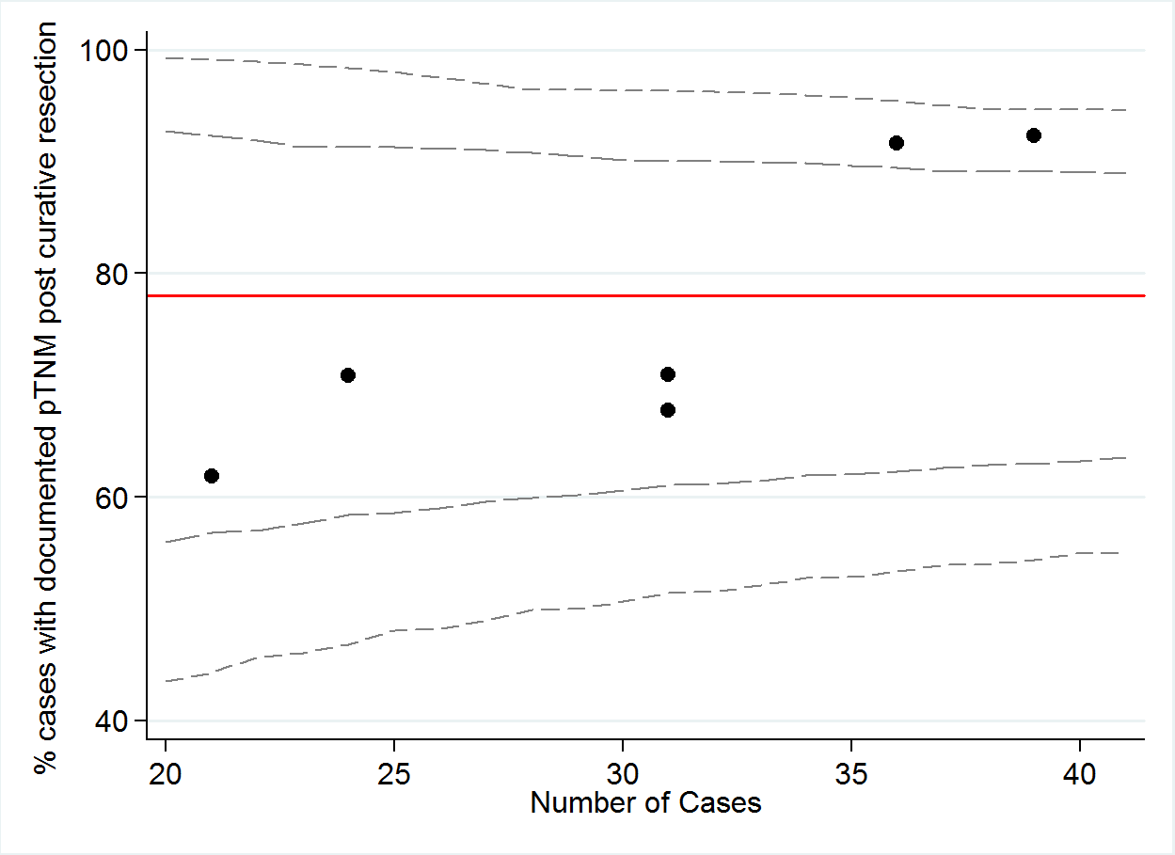

|  |  |  |  |  |  |  |  |  |  |
| --- | --- | --- | --- | --- | --- | --- | --- | --- | --- |
|  | A | B | C | D | E | F | G | H | TOTAL |
| Numerator | 21 | 33 | 36 | 17 | 13 | 22 | 3 | 2 | **147** |
| Denominator | 31 | 36 | 39 | 24 | 21 | 31 | 6 | 3 | **191** |
| % | 68 | 92 | 92 | 71 | 62 | 71 | 50 | 67 | **77** |

**QI 8A: NUMBER OF NSCLC PATIENTS + SURGICAL RESECTION WHERE cTNM AGREES WITH pTNM**

|  |  |  |
| --- | --- | --- |
| No. | Numerator | Denominator |
| 8a | Number of NSCLC patients + surgical resection where cTNM agrees with pTNM | Number of patients with NSCLC undergoing surgical resection with cTNM and pTNM available |

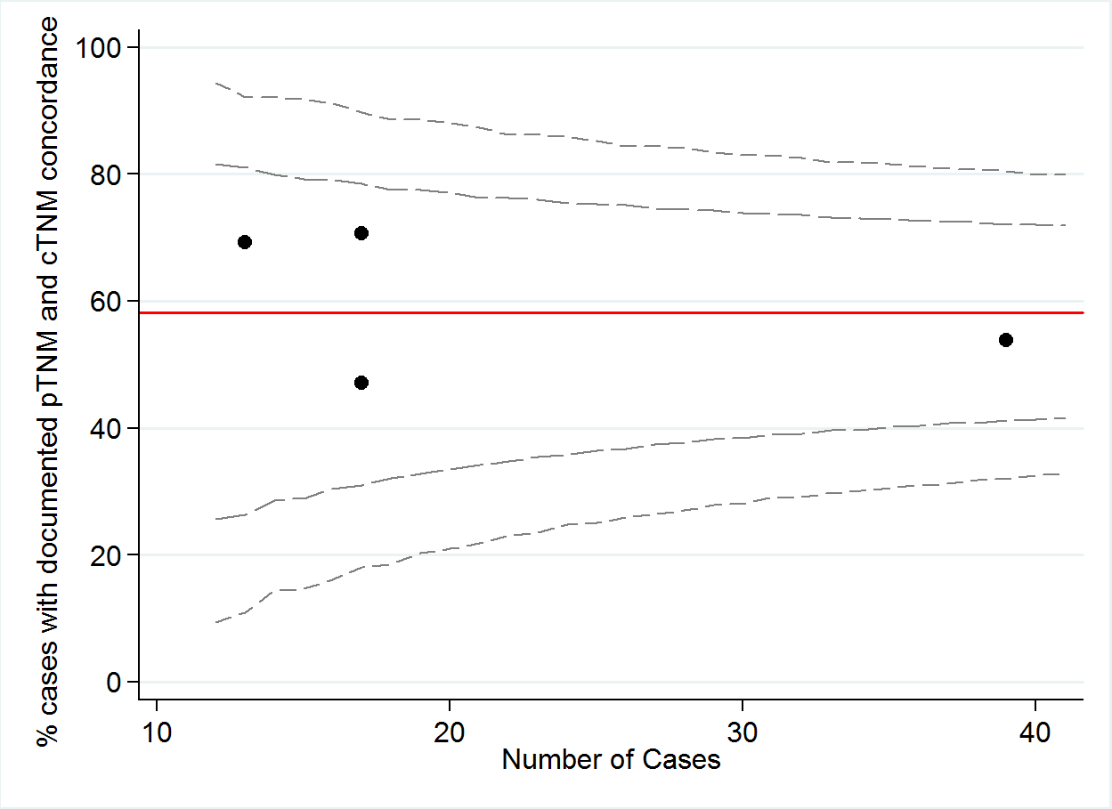

|  |  |  |  |  |  |  |  |  |  |
| --- | --- | --- | --- | --- | --- | --- | --- | --- | --- |
|  | A | B | C | D | E | F | G | H | TOTAL |
| Numerator | 9 | 12 | 21 | 8 | 4 | 9 | 3 | 2 | **68** |
| Denominator | 13 | 17 | 39 | 17 | 4 | 9 | 3 | 2 | **104** |
| % | 69 | 71 | 54 | 47 | 100 | 100 | 100 | 100 | **65** |

**QI 9: NUMBER OF PATIENTS UNDERGOING CURATIVE RESECTION WITH CLEARLY DOCUMENTED PET AT DIAGNOSIS**

|  |  |  |
| --- | --- | --- |
| No. | Numerator | Denominator |
| 9 | Number of patients with clearly documented PET at diagnosis undergoing curative resection | Total number of patients undergoing curative resection |

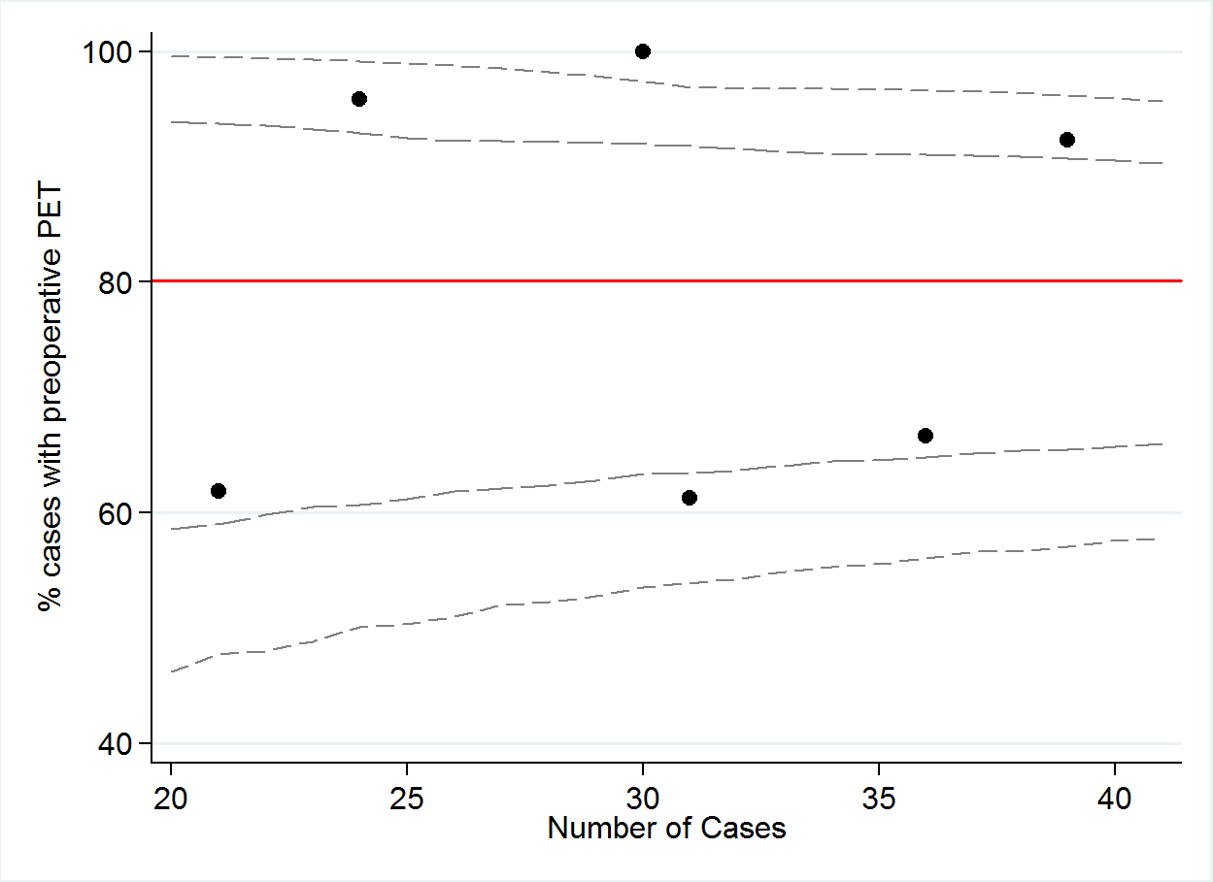

|  |  |  |  |  |  |  |  |  |  |
| --- | --- | --- | --- | --- | --- | --- | --- | --- | --- |
|  | A | B | C | D | E | F | G | H | TOTAL |
| Numerator | 30 | 25 | 37 | 23 | 14 | 19 | 3 | 2 | **153** |
| Denominator | 31 | 36 | 39 | 24 | 21 | 31 | 6 | 3 | **191** |
| % | 97 | 69 | 95 | 96 | 64 | 61 | 50 | 66 | **80** |

**QI 9A: NUMBER OF PATIENTS UNDERGOING CURATIVE TREATMENT.WITH CLEARLY DOCUMENTED PET AT DIAGNOSIS**

|  |  |  |
| --- | --- | --- |
| No. | Numerator | Denominator |
| 9a | Number of patients with clearly documented PET at diagnosis undergoing curative treatment | Total number of patients undergoing curative treatment |

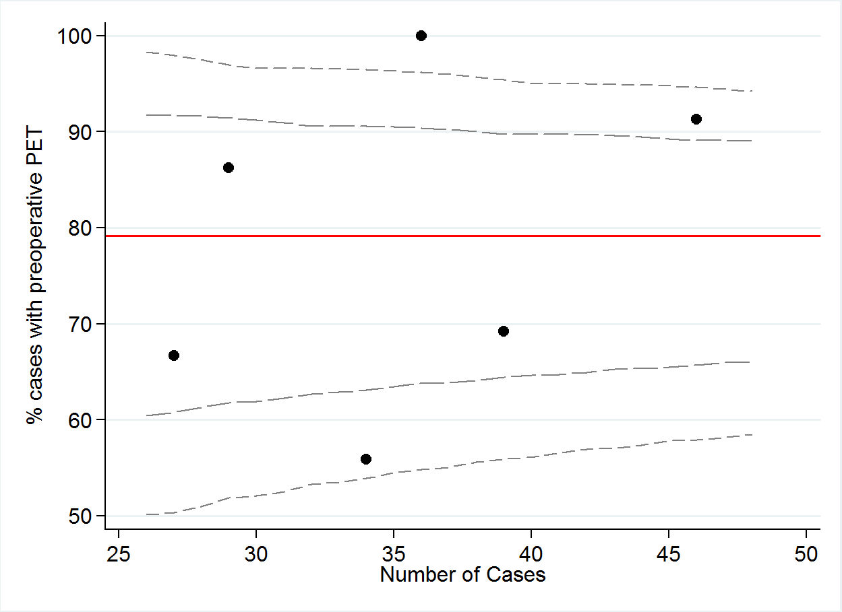

|  |  |  |  |  |  |  |  |  |  |
| --- | --- | --- | --- | --- | --- | --- | --- | --- | --- |
|  | A | B | C | D | E | F | G | H | TOTAL |
| Numerator | 36 | 27 | 42 | 25 | 18 | 19 | 6 | 5 | **178** |
| Denominator | 36 | 38 | 45 | 29 | 27 | 34 | 8 | 5 | **222** |
| % | 100 | 71 | 93 | 86 | 67 | 56 | 75 | 100 | **80** |

**QI 10: NUMBER OF PATIENTS WITH DOCUMENTED PRESENTATION AT AN MULTIDISCIPLINARY MEETING.**

|  |  |  |
| --- | --- | --- |
| No. | Numerator | Denominator |
| 10 | Number of patients with documented presentation at an MDM | Total number of patients in Registry |

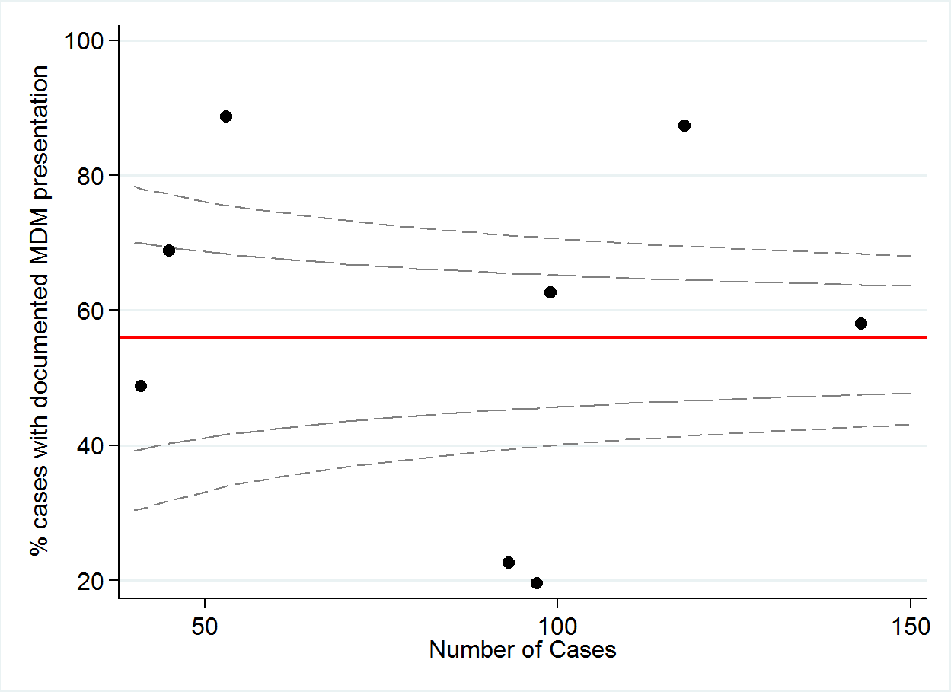

|  |  |  |  |  |  |  |  |  |  |
| --- | --- | --- | --- | --- | --- | --- | --- | --- | --- |
|  | A | B | C | D | E | F | G | H | TOTAL |
| Numerator | 62 | 83 | 103 | 47 | 19 | 21 | 31 | 20 | **386** |
| Denominator | 99 | 143 | 119 | 52 | 97 | 93 | 45 | 41 | **689** |
| % | 63 | 58 | 87 | 89 | 20 | 23 | 69 | 48 | **56** |

**QI 11: NUMBER OF PATIENTS WITH A TISSUE DIAGNOSIS (POSITIVE CYTOLOGY, SPUTUM, BRONCHIAL WASHINGS).**

|  |  |  |
| --- | --- | --- |
| No. | Numerator | Denominator |
| 11 | Number of patients with a tissue diagnosis (Positive cytology, sputum, bronchial washings) | Total number of patients in Registry |

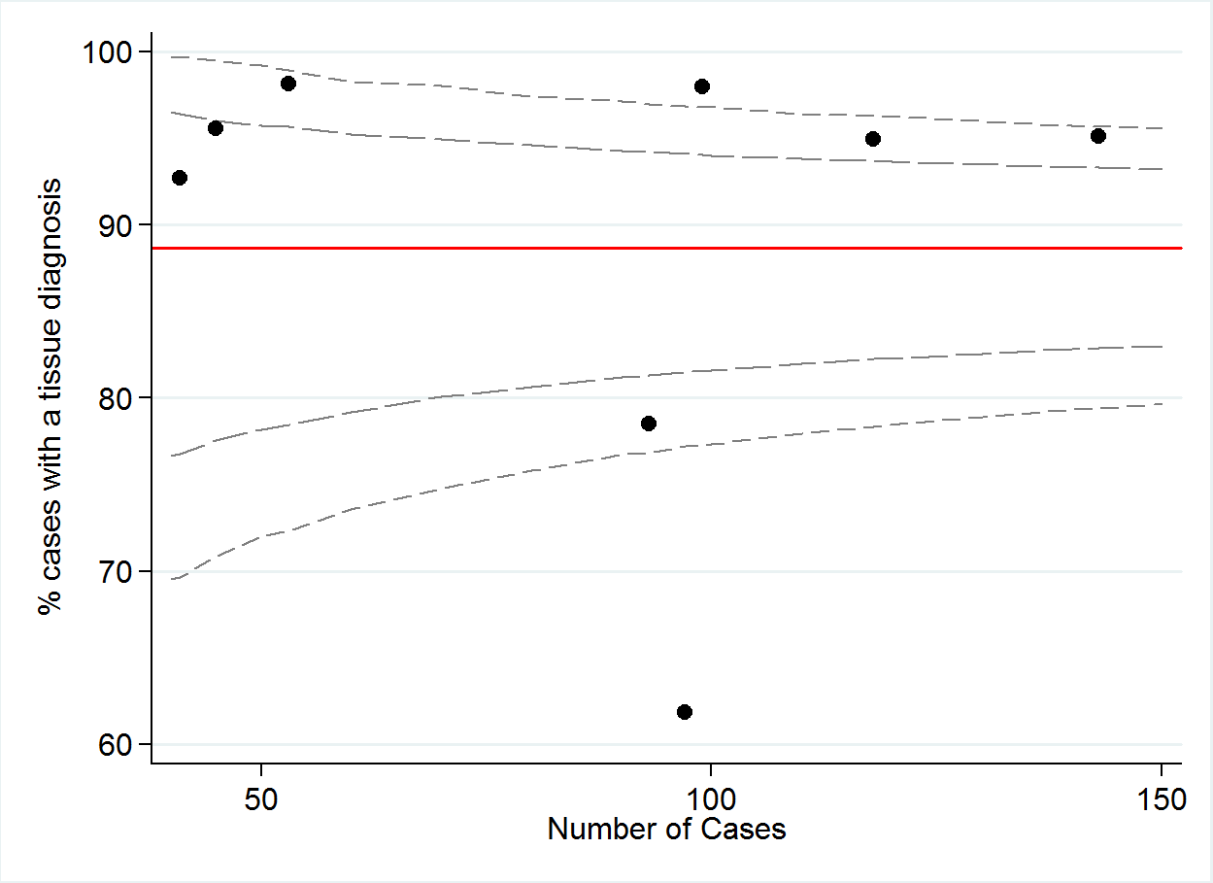

|  |  |  |  |  |  |  |  |  |  |
| --- | --- | --- | --- | --- | --- | --- | --- | --- | --- |
|  | A | B | C | D | E | F | G | H | TOTAL |
| Numerator | 97 | 136 | 112 | 52 | 60 | 73 | 43 | 38 | **611** |
| Denominator | 99 | 143 | 119 | 52 | 97 | 93 | 45 | 41 | **689** |
| % | 98 | 95 | 94 | 100 | 62 | 78 | 96 | 93 | **89** |

# Surgical indicators

**QI 12: NUMBER OF PATIENTS WITH NSCLC + RESECTION (WEDGE + LOBECTOMY + PNEUMONECTOMY).**

|  |  |  |
| --- | --- | --- |
| No. | Numerator | Denominator |
| 12 | Number of patients with NSCLC + resection (wedge + lobectomy + pneumonectomy) | Number of patients with NSCLC |

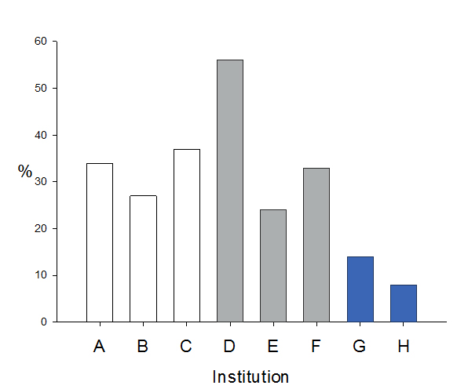

|  |  |
| --- | --- |
|  | Metropolitan Public |
|  | Metropolitan Private |
|  | Regional |

|  |  |  |  |  |  |  |  |  |  |
| --- | --- | --- | --- | --- | --- | --- | --- | --- | --- |
|  | A | B | C | D | E | F | G | H | TOTAL |
| Numerator | 31 | 36 | 39 | 24 | 21 | 31 | 6 | 3 | **191** |
| Denominator | 91 | 131 | 105 | 43 | 86 | 95 | 42 | 38 | **631** |
| % | 34 | 27 | 37 | 56 | 24 | 33 | 14 | 8 | **30** |

**QI 12A: NUMBER OF PATIENTS WITH NSCLC + STAGE I AND II + RESECTION (WEDGE + LOBECTOMY +   
PNEUMONECTOMY).**

|  |  |  |
| --- | --- | --- |
| No. | Numerator | Denominator |
| 12a | Number of patients with NSCLC + stage I and II + resection = (wedge + lobectomy + pneumonectomy) | Number of patients with NSCLC + stage I and II |

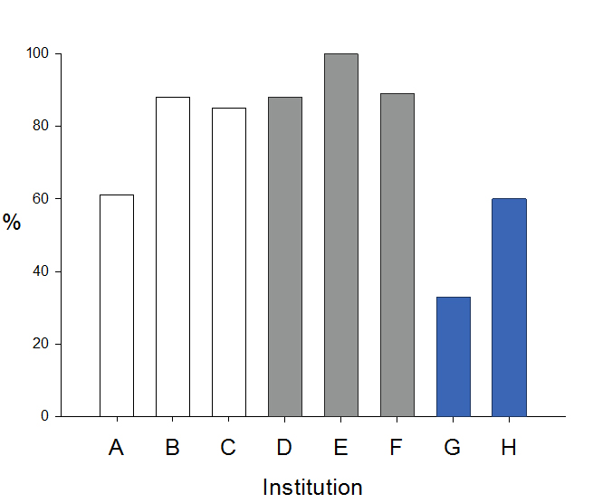

|  |  |  |  |  |  |  |  |  |  |
| --- | --- | --- | --- | --- | --- | --- | --- | --- | --- |
|  | A | B | C | D | E | F | G | H | TOTAL |
| Numerator | 14 | 21 | 35 | 14 | 3 | 8 | 3 | 3 | **101** |
| Denominator | 23 | 24 | 41 | 16 | 3 | 9 | 9 | 5 | **130** |
| % | 61 | 88 | 85 | 88 | 100 | 89 | 33 | 60 | **78** |

**QI 13: NUMBER OF PATIENTS WITH NSCLC + STAGE I AND II + RESECTION (LOBECTOMY).**

|  |  |  |
| --- | --- | --- |
| No. | Numerator | Denominator |
| 13 | Number of patients with NSCLC + stage I and II + resection (lobectomy) | Number of patients with NSCLC stage I and II undergoing surgical resection |

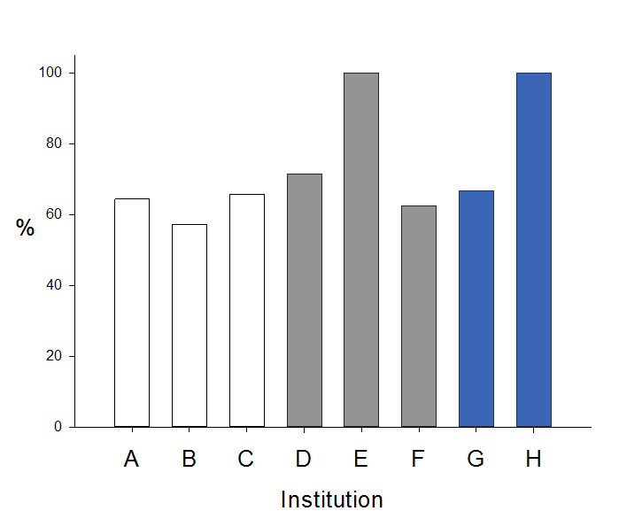

|  |  |  |  |  |  |  |  |  |  |
| --- | --- | --- | --- | --- | --- | --- | --- | --- | --- |
|  | A | B | C | D | E | F | G | H | TOTAL |
| Numerator | 9 | 12 | 23 | 10 | 3 | 5 | 2 | 3 | **67** |
| Denominator | 14 | 21 | 35 | 14 | 3 | 8 | 3 | 3 | **101** |
| % | 64 | 57 | 66 | 71 | 100 | 63 | 67 | 100 | **66** |

**QI 14: NUMBER OF PATIENTS WITH NSCLC + STAGE I AND II + RESECTION (WEDGE + LOBECTOMY + PNEUMONECTOMY) BY VATS APPROACH.**

|  |  |  |
| --- | --- | --- |
| No. | Numerator | Denominator |
| 14 | Number of patients with NSCLC + stage I and II + resection (wedge + lobectomy + pneumonectomy) by VATS approach | Number of patients with NSCLC stage I and II undergoing surgical resection |

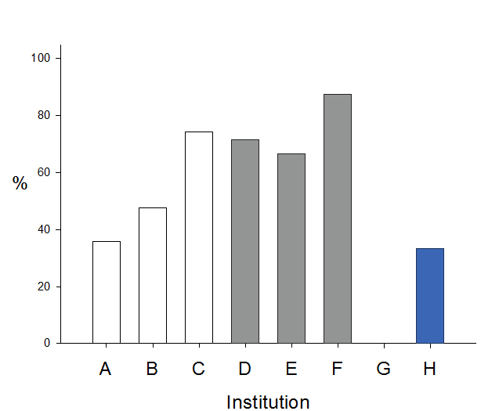

|  |  |  |  |  |  |  |  |  |  |
| --- | --- | --- | --- | --- | --- | --- | --- | --- | --- |
|  | A | B | C | D | E | F | G | H | TOTAL |
| Numerator | 5 | 10 | 26 | 10 | 2 | 7 | 0 | 1 | **61** |
| Denominator | 14 | 21 | 35 | 14 | 3 | 8 | 3 | 3 | **101** |
| % | 36 | 48 | 74 | 71 | 67 | 88 | 0 | 33 | **60** |

**QI 15: NUMBER OF PATIENTS WITH NSCLC + STAGE I AND II + RESECTION (WEDGE + LOBECTOMY + PNEUMONECTOMY) WITH LYMPH NODE DISSECTION.**

|  |  |  |
| --- | --- | --- |
| No. | Numerator | Denominator |
| 15 | Number of patients with NSCLC + stage I and II + resection (wedge + lobectomy + pneumonectomy) with lymph node dissection | Number of patients with NSCLC stage I and II undergoing surgical resection |

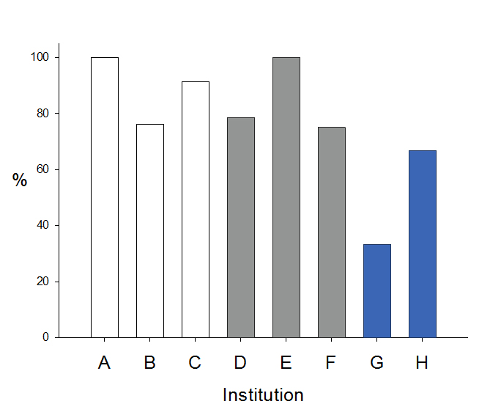

|  |  |  |  |  |  |  |  |  |  |
| --- | --- | --- | --- | --- | --- | --- | --- | --- | --- |
|  | A | B | C | D | E | F | G | H | TOTAL |
| Numerator | 14 | 16 | 32 | 11 | 3 | 6 | 1 | 2 | **85** |
| Denominator | 14 | 21 | 35 | 14 | 3 | 8 | 3 | 3 | **101** |
| % | 100 | 76 | 91 | 79 | 100 | 75 | 33 | 67 | **84** |

**QI 15A: NUMBER OF PATIENTS WITH NSCLC + STAGE I AND II + RESECTION (WEDGE + LOBECTOMY + PNEUMONECTOMY) WITH ≥ 5 LYMPH NODES DISSECTED.**

|  |  |  |
| --- | --- | --- |
| No. | Numerator | Denominator |
| 15a | Number of patients with NSCLC + stage I and II + resection (wedge + lobectomy + pneumonectomy) with ≥ 5 lymph nodes dissected | Number of patients with NSCLC stage I and II undergoing surgical resection |

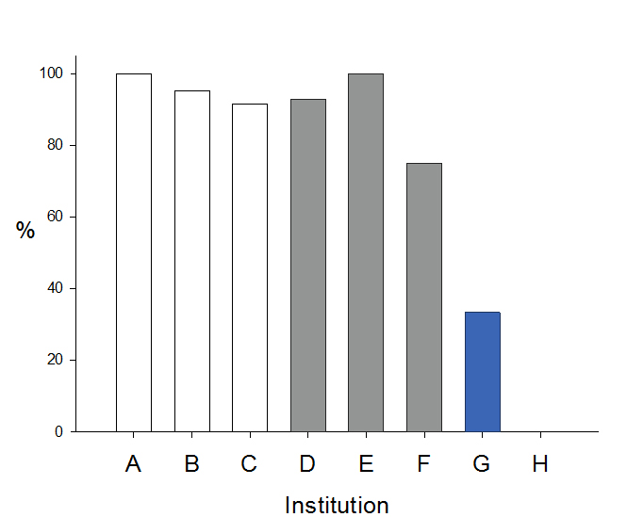

|  |  |  |  |  |  |  |  |  |  |
| --- | --- | --- | --- | --- | --- | --- | --- | --- | --- |
|  | A | B | C | D | E | F | G | H | TOTAL |
| Numerator | 14 | 20 | 32 | 13 | 3 | 6 | 1 | 0 | **89** |
| Denominator | 14 | 21 | 35 | 14 | 3 | 8 | 3 | 3 | **101** |
| % | 100 | 95 | 91 | 93 | 100 | 75 | 33 | 0 | **88** |

**QI 16: NUMBER OF PATIENTS WITH NSCLC UNDERGOING CURATIVE SURGICAL RESECTION WHERE TIME BETWEEN OPERATION DATE AND DEATH DATE IS LESS THAN OR EQUAL TO 30 DAYS.**

|  |  |  |
| --- | --- | --- |
| No. | Numerator | Denominator |
| 16 | Number of NSCLC patients +surgical resection with death date within 30 days of resection | Number of patients with NSCLC who have undergone surgical resection |

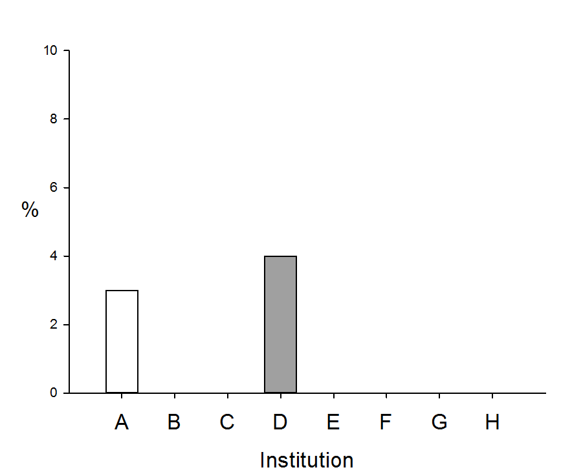

|  |  |  |  |  |  |  |  |  |  |
| --- | --- | --- | --- | --- | --- | --- | --- | --- | --- |
|  | A | B | C | D | E | F | G | H | TOTAL |
| Numerator | 1 | 0 | 0 | 1 | 0 | 0 | 0 | 0 | **2** |
| Denominator | 31 | 36 | 39 | 24 | 21 | 31 | 6 | 3 | **191** |
| % | 3 | 0 | 0 | 4 | 0 | 0 | 0 | 0 | **1** |

# Chemotherapy and radiotherapy indicators

**QI 17: NUMBER OF PATIENTS WITH STAGE III and IV NSCLC + GOOD PERFORMANCE STATUS (ECOG 0-1) UNDERGOING CHEMOTHERAPY**

|  |  |  |
| --- | --- | --- |
| No. | Numerator | Denominator |
| 17 | Number of patients with stage III and IV NSCLC + good performance status (ECOG 0-1) + chemotherapy | Number of patients with NSCLC stage III and IV + ECOG 0-1 |

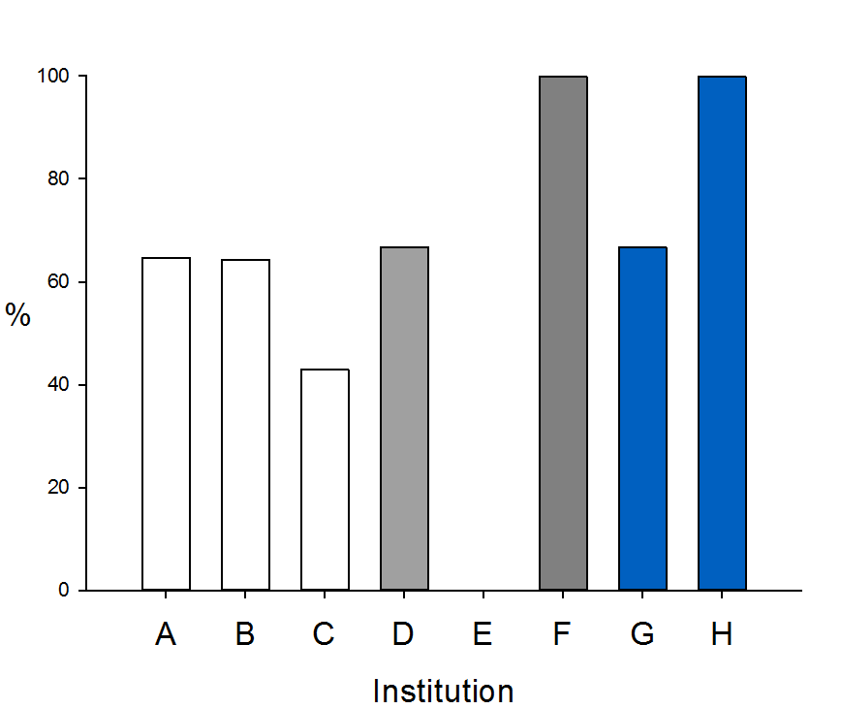

|  |  |  |  |  |  |  |  |  |  |
| --- | --- | --- | --- | --- | --- | --- | --- | --- | --- |
|  | A | B | C | D | E | F | G | H | TOTAL |
| Numerator | 11 | 9 | 6 | 4 | 0 | 13 | 4 | 4 | **24** |
| Denominator | 17 | 14 | 14 | 6 | 2 | 13 | 6 | 4 | **76** |
| % | 65 | 64 | 43 | 67 | 0 | 100 | 67 | 100 | **32** |

**QI 18: NUMBER OF PATIENTS WITH STAGE III+IV NSCLC + GOOD PERFORMANCE STATUS (ECOG 0-1) + PLATINUM-BASED AGENT + NON PLATINUM + RADIOTHERAPY.**

|  |  |  |
| --- | --- | --- |
| No. | Numerator | Denominator |
| 18 | Number of patients with stage III and IV NSCLC + good performance status (ECOG 0-1) + platinum-based agent + non platinum + radiotherapy | Number of patients with NSCLC stage III and IV + ECOG 0-1 |

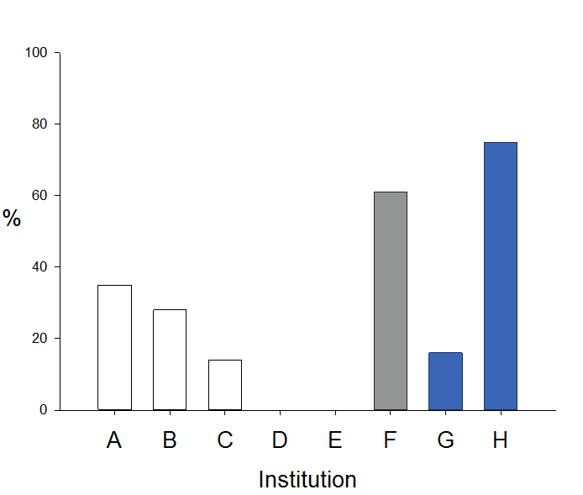

|  |  |  |  |  |  |  |  |  |  |
| --- | --- | --- | --- | --- | --- | --- | --- | --- | --- |
|  | A | B | C | D | E | F | G | H | TOTAL |
| Numerator | 6 | 4 | 2 | 0 | 0 | 8 | 1 | 3 | **24** |
| Denominator | 17 | 14 | 14 | 6 | 2 | 13 | 6 | 4 | **76** |
| % | 35 | 29 | 14 | 0 | 0 | 62 | 17 | 75 | **32** |

**QI 19 NUMBER OF PATIENTS WITH COMPLETELY RESECTED PATHOLOGIC STAGE IIA AND OR IIB NSCLC + GOOD PERFORMANCE STATUS (ECOG 0-2) + LUNG RESECTION + PLATINUM BASED CHEMOTHERAPY.**

|  |  |  |
| --- | --- | --- |
| No. | Numerator | Denominator |
| 19 | Number of patients with completely resected pathologic stage IIA and or IIB NSCLC + good performance status (ECOG 0-1) + lung resection + platinum based chemotherapy | Number of patients with NSCLC + stage IIA and IIB + ECOG 0-1 + resection |

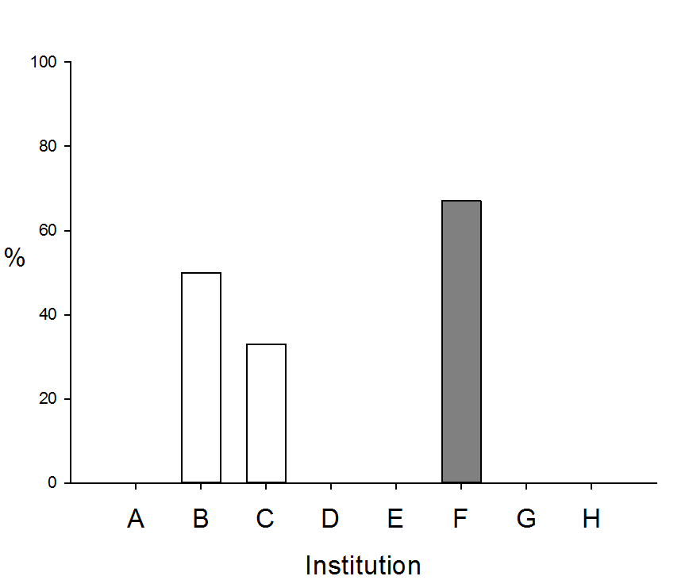

|  |  |  |  |  |  |  |  |  |  |
| --- | --- | --- | --- | --- | --- | --- | --- | --- | --- |
|  | A | B | C | D | E | F | G | H | TOTAL |
| Numerator | 0 | 2 | 1 | 0 | 0 | 2 | 0 | 0 | **5** |
| Denominator | 1 | 4 | 3 | 1 | 0 | 3 | 0 | 0 | **12** |
| % | 0 | 50 | 33 | 0 | 0 | 67 | 0 | 0 | **40** |

**QI 20: NUMBER OF DECEASED PATIENTS WITH LUNG CANCER WHERE TIME BETWEEN CHEMOTHERAPY START DATE AND DEATH DATE IS LEAST THAN OR EQUAL TO 30 DAYS.**

|  |  |  |
| --- | --- | --- |
| No. | Numerator | Denominator |
| 20 | Number of deceased patients with lung cancer where time between chemotherapy start date and death date Is least than or equal to 30 days | Number of patients receiving chemotherapy |

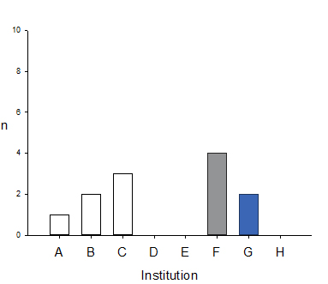

|  |  |  |  |  |  |  |  |  |  |
| --- | --- | --- | --- | --- | --- | --- | --- | --- | --- |
|  | A | B | C | D | E | F | G | H | TOTAL |
| Numerator | 1 | 2 | 3 | 0 | 0 | 4 | 1 | 0 | **11** |
| Denominator | 32 | 58 | 41 | 24 | 30 | 62 | 17 | 23 | **287** |
| % | 3 | 3 | 7 | 0 | 0 | 6 | 6 | 0 | **4** |

**QI 21: NUMBER OF LIMITED STAGE (STAGE I – III) SMALL CELL LUNG CANCER PATIENTS + CHEMOTHERAPY + CONCURRENT THORACIC RADIOTHERAPY WITH FIRST CYCLE CHEMO (WHERE DAYS BETWEEN CHEMOTHERAPY START DATE AND RADIOTHERAPY START DATE IS EQUAL TO 14 DAYS OR LESS.)**

|  |  |  |
| --- | --- | --- |
| No. | Numerator | Denominator |
| 21 | Number of limited stage (Stage I – III) small cell lung cancer patients + chemotherapy + concurrent thoracic radiotherapy with first cycle chemo (where days between chemotherapy start date and radiotherapy start date is equal to 14 days or less) | Number or patients with limited stage SCLC receiving chemotherapy |

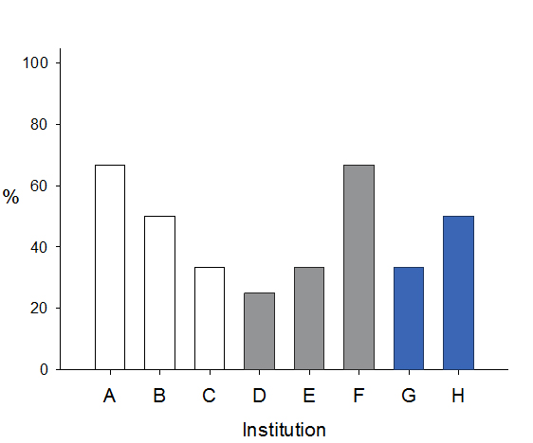

|  |  |  |  |  |  |  |  |  |  |
| --- | --- | --- | --- | --- | --- | --- | --- | --- | --- |
|  | A | B | C | D | E | F | G | H | TOTAL |
| Numerator | 2 | 2 | 3 | 1 | 1 | 2 | 1 | 1 | **13** |
| Denominator | 3 | 4 | 9 | 4 | 3 | 3 | 3 | 2 | **31** |
| % | 67 | 50 | 33 | 25 | 33 | 67 | 33 | 50 | **42** |

# Active treatment indictors

**QI 22: NUMBER OF PATIENTS RECEIVING ACTIVE CANCER TREATMENT (TREATMENT IS DEFINED AS ANY INTENT SURGERY, RADIOTHERAPY, CHEMOTHERAPY, EXCLUDING PALLIATIVE CARE**

|  |  |  |
| --- | --- | --- |
| No. | Numerator | Denominator |
| 22 | Number of patients receiving active cancer treatment (Treatment is defined as any intent surgery, radiotherapy, chemotherapy, excluding palliative care) | Total number of patients in Registry |

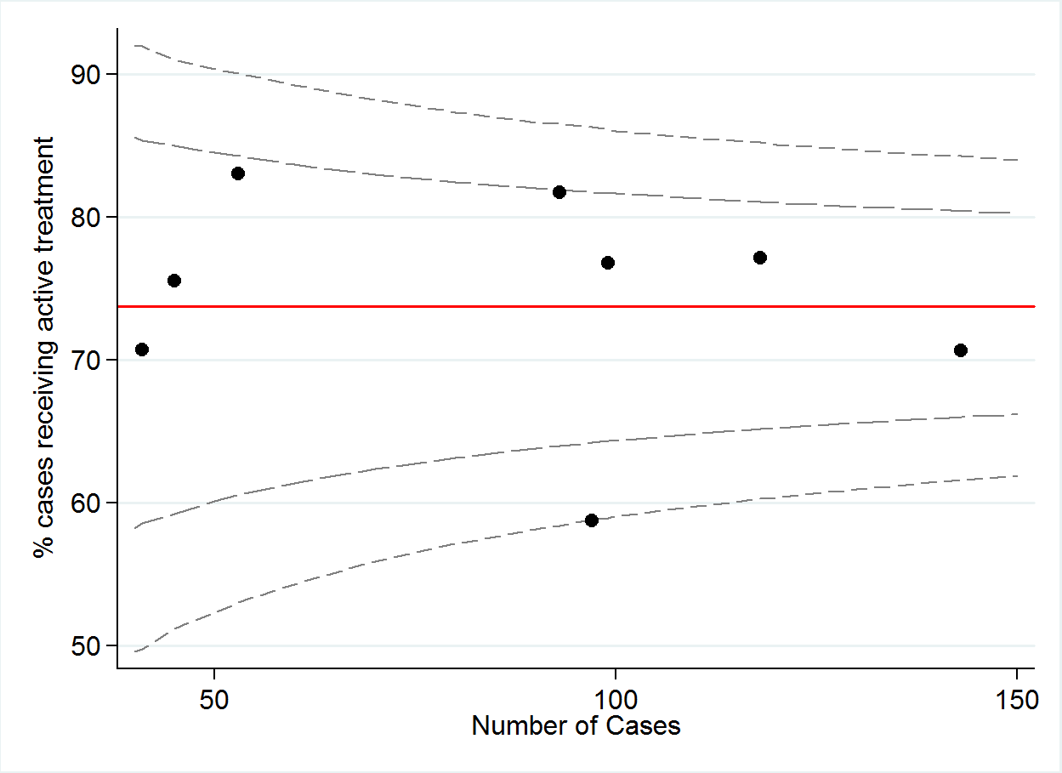

|  |  |  |  |  |  |  |  |  |  |
| --- | --- | --- | --- | --- | --- | --- | --- | --- | --- |
|  | A | B | C | D | E | F | G | H | TOTAL |
| Numerator | 76 | 101 | 91 | 44 | 57 | 76 | 34 | 29 | **508** |
| Denominator | 99 | 143 | 118 | 53 | 97 | 93 | 45 | 41 | **689** |
| % | 77 | 71 | 77 | 83 | 59 | 82 | 76 | 71 | **74** |

# Palliative care indicators

**QI 23: NUMBER OF PATIENTS WITH STAGE IV NSCLC REFERRED TO PALLIATIVE CARE, WHERE TIME BETWEEN DATE OF DIAGNOSIS AND DATE OF REFERRAL IS THAN OR EQUAL TO 56 DAYS.**

|  |  |  |
| --- | --- | --- |
| No. | Numerator | Denominator |
| 23 | Number of patients with stage IV NSCLC referred to palliative care, where time between date of diagnosis and date of referral is than or equal to 56 days | Number of patients with stage IV NSCLC |

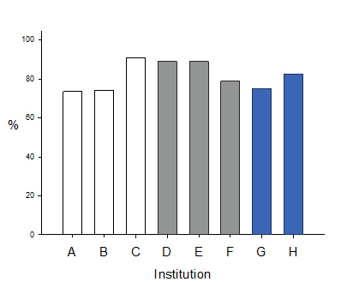

|  |  |  |  |  |  |  |  |  |  |
| --- | --- | --- | --- | --- | --- | --- | --- | --- | --- |
|  | A | B | C | D | E | F | G | H | TOTAL |
| Numerator | 25 | 23 | 39 | 8 | 24 | 15 | 15 | 14 | **163** |
| Denominator | 34 | 31 | 43 | 9 | 27 | 19 | 20 | 17 | **200** |
| % | 74 | 74 | 91 | 89 | 89 | 79 | 75 | 82 | **82** |

# Survival

|  |  |
| --- | --- |
| **Survival curve at 6 months post diagnosis by Stage (I,II,III,IV )** | **Survival curve at 1 year post diagnosis  by Stage (I,II,III,IV)** |
|  |  |
| |  |  |  |  | | --- | --- | --- | --- | |  | **Survival** |  |  | | **Clinical Stage** | Alive | Deaths | Total | | **I** | 85 | 5 | 90 | | **II** | 36 | 4 | 40 | | **III** | 73 | 20 | 93 | | **IV** | 69 | 40 | 109 | | **Total** | **263** | **69** | **332** | | |  |  |  |  | | --- | --- | --- | --- | |  | **Survival** |  |  | | **Clinical Stage** | Alive | Deaths | Total | | **I** | 76 | 14 | 90 | | **II** | 30 | 10 | 40 | | **III** | 64 | 29 | 93 | | **IV** | 54 | 55 | 109 | | **Total** | **224** | **108** | **332** | |
| **Survival curve at 1 year post diagnosis for Stage 1 by region** | **Survival curve at 1 year post diagnosis for stage IV by region** |
|  |  |
| |  |  |  |  |  |  | | --- | --- | --- | --- | --- | --- | | **Survival ( Stage I)** | | | | | | | **Met Public** | | **Met Private** | | **Regional** | | | Alive | Deaths | Alive | Deaths | Alive | Deaths | | 46 | 12 | 26 | 1 | 4 | 1 | | |  |  |  |  |  |  | | --- | --- | --- | --- | --- | --- | | **Survival ( Stage IV)** | | | | | | | **Met Public** | | **Met Private** | | **Regional** | | | Alive | Deaths | Alive | Deaths | Alive | Deaths | | 32 | 32 | 18 | 13 | 4 | 10 | |

# Survival

# VLCR Personnel

The VLCR acknowledges and thanks the investigators, committee members, data collectors and hospital staff for their active involvement and support.

**VLCR staff:**

Dr Rob Stirling (Principal Investigator)

Dr Sue Evans (Data Custodian)

Peta McLaughlin (Project Officer)

Meera Senthuren (Research Officer)

Susan McKenna (Follow up Interviewer)

John Liman (Senior Analyst, Programmer)

Sara McLaughlin- Barrett (Epworth Cardiothoracic Nurse and VLCR Data collector)

Monica Lammers (St Vincent’s’ Hospital and St Vincent’s’ and Mercy Private Hospital, Respiratory Scientist and VLCR Data Collector)

Tina Leeuwrick (Cabrini Data Collector)

Nathan O’Shaughnessy (Alfred Data Collector)

Jessica Callaghan (Administrative Assistant)

**Site Lead Investigators**

A/Prof Paul Mitchell

Dr Matthew Conron

A/Prof Phillip Antippa

A/Prof Gary Richardson

A/Prof David Ashley

# Conclusions

* The registry outcomes for each participating institution are summarised in a blinded fashion with each institution only able to identify their own institution.
* The performance of each institution may be compared to provide benchmarking of relative performance for participating institutions.
* Registry outcomes are reported to each institution via the CEO, Chief Medical Officer, Lung Cancer MDM lead and ethics committee.
* The evaluation of registry outcomes at governance, administrative and clinical levels may identify targets for service improvement and targets for further safety and safety evaluation.
* Registry outcomes may identify areas for improvement as targets for service innovation and development
* The comparison of performance outcomes across institutions and institution sectors may drive competitive recruitment to improve measures on a year on year basis.

# Future directions

* Expanding institutional engagement in registry
* Aim for complete state-wide inclusion
* Evaluate, challenge and refine quality indicators
* Foster research initiatives around registry data
* Explore sustainable funding models
* Develop and extend statewide demand for quality data
* Evaluation of Quality of Life data and development of publication

# References

1. Stirling RG. Clinical quality registries: engaging effectiveness data for quality improvement. Am J Public Health. 2014 Dec;104(12)
2. Stirling RG, Evans SM, McLaughlin P, Senthuren M, Millar J, Gooi J, Irving L, Mitchell P, Haydon A, Ruben J, Conron M, Leong T, Watkins N, McNeil JJ. The Victorian Lung Cancer Registry pilot: improving the quality of lung cancer care through the use of a disease quality registry. Lung. 2014 Oct;192(5):749-58
3. Stirling RG, Evans SM, McNeil JJ. Emerging evidence of a clinical quality registry as a driver of improvement in lung cancer outcomes. J Thorac Oncol. 2014 Mar; 9 (3):e28.
4. Evans SM, Scott IA, Johnson NP, Cameron PA, McNeil JJ. Development of clinical-quality registries in Australia: the way forward. Med J Aust. 2011 Apr 4; 194 (7):360-3.
5. McNeil JJ, Evans SM, Johnson NP, Cameron PA. Clinical-quality registries: Their role in quality improvement. Med J Aust. 2010 Mar 1;192 (5):244-5.
6. Evans SM, Bohensky M, Cameron PA, McNeil J. A survey of Australian clinical registries: can quality of care be measured? Intern Med J. 2011 Jan; 41(1a).

# Appendices

Appendix A: VLCR Quality indicators

|  |  |  |
| --- | --- | --- |
| **No.** | **Numerator** | **Denominator** |
| **Process Indicators:** | | |
| **1** | Number of patients where time from referral date to diagnosis is less than 28 days | Total number of patients in Registry with a referral date available |
| **2** | Number of patients where time from diagnosis date to first treatment date is less than 14 days | Total number of patients in Registry receiving treatment |
| **2a** | Number of patients where time from diagnosis date to surgical resection date is less than 14 days | Total number of patients in Registry undergoing surgical resection |
| **2b** | Number of patients where time from diagnosis date to first chemotherapy treatment date is less than 14 days | Total number of patients in Registry receiving chemotherapy treatment |
| **2c** | Number of patients where time from diagnosis date to first radiotherapy treatment date is less than 14 days | Total number of patients in Registry receiving radiotherapy treatment |
| **2d** | Number of patients treated with both chemotherapy and radiotherapy, where chemotherapy and radiotherapy start dates are within 14 days of each other and time from diagnosis date to first treatment date is less than 14 days | Total number of patients in Registry undergoing combined chemo-radiotherapy treatment. |
| **3** | Number of patients where time from diagnosis date to first treatment date is less than 42 days | Total number of patients in Registry undergoing treatment |
| **3a** | Number of patients where time from diagnosis date to surgical resection date is less than 42 days | Total number of patients in Registry undergoing surgical resection |
| **3b** | Number of patients where time from diagnosis date to first chemotherapy treatment date is less than 42 days | Total number of patients in Registry undergoing chemotherapy |
| **3c** | Number of patients where time from diagnosis date to first radiotherapy treatment date is less than 42 days | Total number of patients in Registry undergoing radiotherapy |
| **3d** | Number of patients who have been treated with both chemotherapy and radiotherapy, where chemotherapy and radiotherapy start dates are within 14 days of each other, and time from diagnosis date to first treatment date is less than 42 days | Total number of patients in Registry undergoing chemo-radiotherapy treatment |
| **4** | Number of patients with documented screening for supportive care | Total number of patients in Registry |
| **5** | Number of patients with documented ECOG status | Total number of patients in Registry |
| **6** | Number of patients with weight loss assessment documented at diagnosis | Total number of patients in Registry |
| **7** | Number of patients with clearly documented cTNM at diagnosis | Number of patients with NSCLC |
| **8** | Number of NSCLC patients + surgical resection with clearly documented pTNM | Number of patients with NSCLC who have undergone surgical resection |
| **8a** | Number of NSCLC patients + surgical resection where cTNM agrees with pTNM | Number of patients with NSCLC undergoing surgical resection with cTNM and pTNM available |
| **9** | Number of patients with clearly documented PET at diagnosis undergoing curative resection | Total number of patients undergoing curative resection |
| **9a** | Number of patients with clearly documented PET at diagnosis undergoing curative treatment | Total number of patients undergoing curative treatment |
| **10** | Number of patients with documented presentation at an MDM | Total number of patients in Registry |
| **11** | Number of patients with a tissue diagnosis (Positive cytology, sputum, bronchial washings) | Total number of patients in Registry |
| **Surgical Indicators:** | | |
| **12** | Number of patients with NSCLC + resection (wedge + lobectomy + pneumonectomy) | Number of patients with NSCLC |
| **12a** | Number of patients with NSCLC + stage I and II + resection (wedge + lobectomy + pneumonectomy) | Number of patients with NSCLC + stage I and II |
| **13** | Number of patients with NSCLC + stage I and II + resection (lobectomy) | Number of patients with NSCLC stage I and II undergoing surgical resection |
| **14** | Number of patients with NSCLC + stage I and II + resection (wedge + lobectomy + pneumonectomy) by VATS approach | Number of patients with NSCLC stage I and II undergoing surgical resection |
| **15** | Number of patients with NSCLC + stage I and II + resection (wedge + lobectomy + pneumonectomy) with lymph node dissection | Number of patients with NSCLC stage I and II undergoing surgical resection |
| **15a** | Number of patients with NSCLC + stage I and II + resection (wedge + lobectomy + pneumonectomy) with ≥ 5 lymph nodes dissected | Number of patients with NSCLC stage I and II undergoing surgical resection |
| **16** | Number of patients with NSCLC where time between operation date and death date is less than or equal to 30 days | Number of patients with NSCLC undergoing surgical resection |
| **Chemotherapy and Radiotherapy Indicators:** | | |
| **17** | Number of patients with stage III and IV NSCLC + good performance status (ECOG 0-1) undergoing chemotherapy | Number of patients with NSCLC stage III and IV + ECOG 0-1 |
| **18** | Number of patients with stage III and IV NSCLC + good performance status (ECOG 0-1) + platinum-based agent + non platinum + radiotherapy | Number of patients with NSCLC stage III and IV + ECOG 0-1 |
| **19** | Number of patients with completely resected pathologic stage IIA and or IIB NSCLC + good performance status (ECOG 0-2) + lung resection + platinum based chemotherapy | Number of patients with NSCLC + stage IIA and IIB + ECOG 0-2 + resection |
| **20** | Number of deceased patients with lung cancer where time between chemotherapy start date and death date Is least than or equal to 30 days | Number of patients receiving chemotherapy |
| **21** | Number of limited stage (Stage I – III) small cell lung cancer patients + chemotherapy + concurrent thoracic radiotherapy with first cycle chemo (where days between chemotherapy start date and radiotherapy start date is equal to 14 days or less) | Number or patients with limited stage SCLC receiving chemotherapy |
| **Active treatment Indicators:** | | |
| **22** | Number of patients receiving active cancer treatment (Treatment is defined as any intent surgery, radiotherapy, chemotherapy, excluding palliative care) | Total number of patients in Registry |
| **Palliative care Indicators:** | | |
| **23** | Number of patients with stage IV NSCLC referred to palliative care, where time between date of diagnosis and date of referral is than or equal to 56 days | Number of patients with stage IV NSCLC |

Appendix B: VLCR Governance

### Steering Committee

|  |  |
| --- | --- |
| **Name** | **Organisation and Title** |
| **A/Prof David Ashley** | Director of Medical Oncology, Barwon Health. |
| **Professor David Ball** | Deputy Director, Radiation Oncology & Cancer Imaging, Chair, Lung Service, Peter MacCallum Cancer Centre. |
| **Dr Peter Briggs** | Medical Director SMICS / Head of Oncology, Southern Health. |
| **Shirley Carvosso** | Consumer Representative. |
| **Dr Matthew Conron** | Director, Department Respiratory and Sleep Medicine, St Vincent’s Melbourne. |
| **Mary Duffy** | Lung nurse coordinator at Peter MacCallum Cancer Centre, Melbourne. |
| **Dr Sue Evans** | Head Clinical Registries Unit, Department of Epidemiology and Preventive Medicine (DEPM), Monash University. |
| **Helen Farrugia** | Director Victorian Cancer Registry, Cancer Council Victoria. |
| **A/Prof Vinod Ganju** | Medical Oncologist and Haematologist, Peninsula Oncology Centre. |
| **Prof Louis Irving** | Director/Respiratory & Sleep Disorders Physician, Department of Respiratory and Sleep Medicine, Royal Melbourne Hospital Melbourne. |
| **A/Prof David Langton** | Respiratory & Sleep Physician, Frankston Hospital. |
| **Prof Michael MacManus** | Associate Director (Research), Radiation Oncologist, Department of Radiation Oncology**,** Peter MacCallum Cancer Centre, Melbourne. |
| **Prof John McNeil** | Head of Department of Epidemiology & Preventive Medicine, Head of School of Public Health & Preventive Medicine, Monash University. |
| **A/Prof Jeremy Millar** | Director Radiation Oncology, William Buckland Radiotherapy Centre, Alfred Health & William Buckland Radiotherapy Centre, Gippsland. |
| **A/Prof Paul Mitchell** | Associate Professor, University of Melbourne, Director, North-Eastern Melbourne Integrated Cancer Service, President, Australasian Lung Cancer Trials Group, Olivia Newton-John Cancer and Wellness Centre. |
| **A/Prof Jennifer Philip** | Co-Deputy Director, Centre for Palliative Care & Deputy Director of Palliative Medicine, St Vincent's. |
| **A/Prof Gary Richardson** | Director of Cabrini Academic Haematology & Oncology Service, Associate Professor of Medicine, Monash University, Chairman, Foundation 4, Private Cancer Physicians of Australia, Chairman, Medical Oncology Group of Australia. |
| **Dr Megan Robertson** | Executive Director of Research, Epworth HealthCare. |
| **A/Prof Ben Solomon** | Medical Oncologist, Head Lung cancer Medical Oncology Service at Peter MacCallum Cancer Centre. |
| **A/Prof Rob Stirling** | Principal Investigator, Steering Group Chairman, Victorian Lung Cancer Registry, Consultant Physician, Department of Allergy Immunology & Respiratory Medicine, The Alfred Hospital |
| **Maureen Turner** | Chief Executive Officer, BioGrid Australia. |
| **Prof Neil Watkins** | Petre Chair in Cancer Biology, Lab Head - Cancer Developmental Biology, Garvan Institute, Sydney, NSW. |
| **A/Prof Gavin Wright** | Director of Surgical Oncology, St Vincent’s Hospital Melbourne. |
| **Professor John Zalcberg** | Head, Cancer Research. School of Public Health and Preventive Medicine, Monash University. |

Management Committee

Management Committee is responsible for managing the day-to-day aspects of the clinical registry. Data quality measures are reported regularly to the management committee. Management Committee members include:

|  |  |
| --- | --- |
| **Name** | **Organisation** |
| **A/Prof Rob Stirling** | Steering Committee Chair, Principal Investigator VLCR, Respiratory Physician, Alfred Health |
| **Dr Sue Evans** | Head: Clinical Registries Unit, School of Public Health & Preventive Medicine, Monash University. |
| **Dr Julian Gooi** | Cardiothoracic Surgeon, Alfred Health. |
| **A/Prof Jennifer Phillips** | Deputy Director, Palliative Medicine & Centre for Palliative Care, St Vincent's Hospital. |
| **Dr Andrew Haydon** | Medical Oncologist, Alfred Health |
| **Dr Jeremy Ruben** | Radiation Oncologist, William Buckland Radiotherapy Centre, The Alfred, RANZCR Training Network Director, Victoria. |

## Appendix C: Investigation into VLCR case ascertainment completeness

**Summary:** A quantitative, case finding audit was employed to evaluate the case ascertainment methodology and assess capture completeness at a Victorian public and private metropolitan hospital.

**Methods:** Lists of lung cancer patients recorded for the period 01/07/2011 and 30/06/2012 were requested from institutional departments including; Radiotherapy, Palliative Care, Day Procedure Unit, Oncology Lung Multidisciplinary Team Meeting (MDM), Cardiothoracic Surgery (CTS), Pathology and the Victorian Cancer Registry (VCR). Comparisons were made between VLCR administrative capture versus clinical capture achieved by the use of clinical databases compared with mandated VCR capture.

**Results**: The VLCR registered 125 new cases in Site A and 96 in Site B. A total of 10 (7.5%) patients in Site A and 30 (23.5%) patients in Site B had not been recruited by the registry. Investigations indicated that the underreporting of these cases was attributed to the use of the ICD10 R91 Code (when lung cancer is suspected but not confirmed) in site A and non-coded day patients (e.g. day admissions, direct admission to palliative care or MDM) in site B.

**Conclusion:** The completeness of capture of incident cancers occurring in a population and included in a registry database is a vital attribute of a cancer registry. Inclusion of the R code and an attempt to capture un-coded patients will ensure registry incidence rates are close to their true value.

|  |  |  |  |  |  |  |  |  |  |  |  |  |  |  |  |  |  |  |  |  |  |  |  |  |  |  |  |  |  |  |  |  |  |  |  |  |  |  |  |  |  |  |  |  |  |  |  |  |  |  |  |  |  |  |  |  |  |
| --- | --- | --- | --- | --- | --- | --- | --- | --- | --- | --- | --- | --- | --- | --- | --- | --- | --- | --- | --- | --- | --- | --- | --- | --- | --- | --- | --- | --- | --- | --- | --- | --- | --- | --- | --- | --- | --- | --- | --- | --- | --- | --- | --- | --- | --- | --- | --- | --- | --- | --- | --- | --- | --- | --- | --- | --- | --- |
| **Site 1**   |  |  |  |  |  |  |  | | --- | --- | --- | --- | --- | --- | --- | | Database | Total presentations | Ineligible | Incidence | Already on VLCR | No of patients not in VLCR | Total number added to registry | | MDM | **271** | **184** | **87** | **70** | 17 | 8 | | WBRC | **163** | **104** | **59** | **52** | 7 | 2 | | CTS | **124** | **86** | **38** | **34** | 4 | 0 | | VCR | **192** | **64** | **126** | **119** | 7 | 0 | | Pathology | **12** | **1** | **11** | **5** | 6 | 0 | | Radiology | **93** | **53** | **40** | **37** | 3 | 0 | | Total |  |  |  |  |  | 10 | |  |
|  |  |
| **Site 2**   |  |  |  |  |  |  |  | | --- | --- | --- | --- | --- | --- | --- | | Database | Total presentations | Ineligible | Incidence | Already on VLCR | No of patients not in VLCR | Total number (added to registry ) | | MDM | **97** | **59** | **35** | **24** | **11** | **9** | | Pall. Care | **54** | **40** | **14** | **9** | **5** | **4** | | VCR | **176** | **64** | **106** | **73** | **33** | **12** | | Radiotherapy | **89** | **49** | **40** | **22** | **18** | **5** | | Total |  |  |  |  |  | **30** | |  |

## Appendix D: VLCR Escalation policy

The Lung Cancer Registry is responsible for collection and analysis of treatment and outcome data. Outcome data routinely reported by the registry includes treatment, time to treatment and mortality. With this activity comes the responsibility to act upon outliers identified by the registry.

An outlier escalation policy has been developed, in line with other clinical registries, to ensure that if any clinicians are providing sub-optimal care they may be identified and strategies are put in place to prevent patient harm.

No monitoring system can reliably separate “true inliers” from the “true outliers.” This is because of the complexity and variations inherent in patients and healthcare services and the inaccuracy of monitoring methodologies. Therefore a three-stage graded response system is proposed with escalation to the next stage if an alert has occurred during the previous stage.

The escalation policy will relate to outliers in terms of increased mortality rate compared to peer organisations, following diagnosis of lung cancer. Mortality rates will adjust for factors known to impact on mortality. Disease pathology, age, staging and ECOG status will be used to categorise patients according to risk. These adjusted rates will then be compared with peer organisations.

The **Level 1** alert or “warning” trigger is set to flag at a statistically significant change from the benchmark of two standard deviations from the mean. If a Level 1 alert is reached data are checked for accuracy and the outlier clinician will be notified. Data will be reviewed for accuracy. If ’outlier status’ is deemed by the Steering Committee not to be a data quality issue the Medical Director or Head of Unit will then be notified.

A **Level 2** alert or “investigation” trigger is set at three standard deviations from the mean. If a Level 2 is reached then the following processes are initiated under direction of the Steering Committee:

Data will again be checked for major errors e.g. validate against hospital records and devices, ensure data entry are correct.

Data will be checked for major shifts in that clinician’s demographic and casemix. e.g. compare age, sex and comorbidity profile.

Assess whether there are casemix factors peculiar to this clinician that may explain the observed variations

Following this review, confidential communication to the relevant clinician will be provided with results of preliminary analysis and an explanatory report. If an outlier is identified, contact will be made with the Executive Medical Director or the Chairman of the relevant Ethics Committee. This report will also be made available to the Head of Unit or Medical Director. Should this investigation not produce a suitable explanation for an anomaly, investigation will proceed to Level 3.

A **Level 3** alert is flagged if the Level 2 alert persists for more than two consecutive quarters or as above. As with a Level 2 flag, the aim of this stage is to identify and exclude common factors that may have lead to a false alarm. Here is a suggested action plan:

All of Stage 2 is undertaken (if not already completed) ***and***

Check for calculation errors, such as an inadvertent model coefficient error or an incorrect risk-adjustment formula, ***and***

If necessary, extract raw data a second time and re-calculate risk-adjustment models.

Identify if there have been significant changes in the recalibrated model(s)

Should this investigation not provide a suitable explanation for the alert signal(s) a peer review process and audit will be undertaken in collaboration with the institution. The Steering Committee will recommend targeted investigation focusing on areas which are likely to be helpful including, but not limited to the following issues:

***Patient factors***

Is there significant variation in casemix?

Has the casemix shifted?

Have referral patterns changed?

***Structure and resource availability.***

Has there been a change in data collection practices e.g. personnel changes, IT software/hardware changes, data submission?

Have clinical services been substantially altered? e.g. increased workload

Has there been a change in funding?

Has there been a change in resources?

Has there been a change in clinical services?

Is there an internal clinical audit process?

Do these internal audit reports highlight areas of interest?

Within a one month period, the clinician and the Director of Medical Services or Head of Unit will be notified with a written report of the findings of this review. Recommendations will be made e.g. improvement to resources, staffing, training, clinical audit, peer review. Issues will be raised with the Chief Executive Officer if the committee is not satisfied with explanation for persistent outlier status in regard to mortality and if actions are not initiated

## Appendix E: VLCR Publications, presentations and awards

|  |  |
| --- | --- |
| Awards | |
| Epworth Research Institute. Small Research grant: $10,000. Improvement in quality of care provided to lung cancer patients at Epworth Healthcare through the support and development of the Victorian Lung Cancer Registry. | 2014 |
| Highly Commended Award: Alfred Health Chairman of the Board Awards for Patient Safety and Quality Improvement. | 2012 |
| Journal Publications | |
| The Victorian Lung Cancer Registry Pilot: Improving the Quality of Lung Cancer Care Through the Use of a Disease Quality Registry, Lung, June 2014 | June, 2014 |
| Poster Presentations |  |
| IASLC 15th World Conference on Lung Cancer. Sydney. Determining completeness of case ascertainment to a lung cancer registry: A single institutional study. | October, 2013 |
| HISA (Health Informatics Society of Australia), Big Data Conference, Melbourne. Development of a Secure Data Transfer Protocol Service for Australian Clinical Quality Registries. The Monash University Experience. | April, 2013 |
| ATS, American Thoracic Society Conference, San Francisco, California. Quality in lung cancer care: The development of a population based lung cancer registry | May, 2012 |
| ALCC – Australasian Lung Cancer Conference. Adelaide, SA. Quality in lung cancer care: development of a population based lung cancer registry. | October, 2013 |
| ALCC Australasian Lung Cancer Conference, Brisbane QLD. Determining completeness of case ascertainment to a lung cancer registry: A case finding audit. | October,2014 |
| Oral Presentations | |
| Thoracic Society of Australia and New Zealand 2012 ASM. Canberra. The development of a population based lung cancer registry. | April, 2012 |
| Monash Comprehensive Cancer Consortium (MCCC): Cancer Registries - Joining the Dots: Linking Clinic, Laboratory and Patient Populations, Monash University, Melbourne. | April, 2012 |
| AAQHC - Australasian Conference on Safety and Quality in Health Care. Cairns, QLD. Lung cancer: An urgent call for quality assurance. The development of a population based lung cancer registry. | September, 2012 |
| Grands Rounds. Alfred Health, VLCR Report. Melbourne. | November, 2013 |
| Australian Lung Cancer Conference. Brisbane, QLD   * Health service variables impact timelines of care in Victorian lung cancer patients. * Quality in lung cancer care: The Victorian lung cancer registry pilot initial report. * Gap analysis of Victorian Lung Cancer Registry Data after 3 years: Evaluation of MDT variables * A comparison of the use of ICD-10 coding data and manual data extraction in comorbidity | October, 2014 |

## Appendix F: VLCR Funding

The VLCR pilot study was established in late 2010 following a successful grant application to the Victorian Cancer Agency. The VLCR pilot study was funded for 3 years with a total budget of $608,202.

|  |  |  |  |
| --- | --- | --- | --- |
| Organisation | Funding ($) | | |
|  | **2012** | **2013** | **2014** |
| Victorian Cancer Agency | $202,734 | $202,734 | $202,734 |
| Total Funding received | **$608,202** | | |

## Appendix G: Glossary

|  |  |
| --- | --- |
| **cTNM** | Clinical stage of primary tumour |
| **pTNM** | Pathological stage of primary tumour |
| **PET** | Positron emission tomography scan |
| **CT** | Computed tomography scan |
| **VLCR** | Victorian Lung Cancer Registry |
| **ECOG** | Eastern Cooperative Oncology Group Performance status score |
| **ICD 10** | 10th revision of the International Statistical Classification of Diseases and Related Health Problems (ICD) |
| **NSCLC** | Non small cell lung cancer |
| **SCLC** | Small cell lung cancer |
| **VATS** | Video-assisted thoracoscopic surgery |

